Kisoma Dhopadhola
Kitabo Marapena
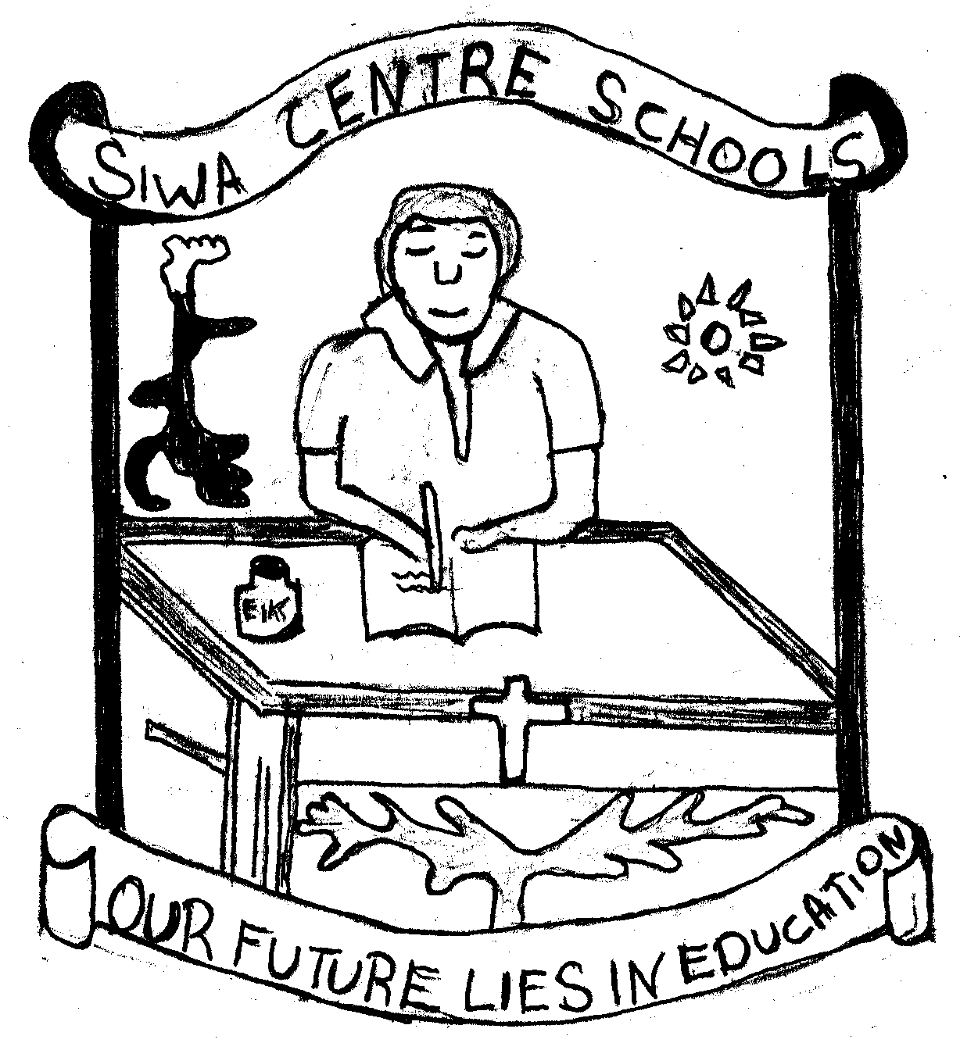

Kitabo Marapena

Wafwoyo swa ji jye, somero ma Siwa kod Miganja Praimari. Walwa:
Athieno Gertrude
Nyadoi Evaline Mijasi
Nyadoi Immaculate
Nyafwono Connie
Nyaketcho Jane Irene
Nyawere Magdalen
Ochwo Wilbrod
Okech Michael
Owino Joseph
Owor Moses Jambaka
Owor-Obel Joyce
Emerikwa Michael
Masaba Godfrey
Odongo Donato
Opio Julius
Oyo Aloysius kod
Oyuk-Oracho Julius
Okoth Mariko omo kitabo me ma fwonjo Dhopadhola ri nyithindho ma praimari. Medo nyayo kitabo me ri fwonji maber swa. Bende inyalo nwaŋo kitabo me http://mark.risse.com.

Kitabo me nitye gi kigana kod gikipiny ma fwonji ondiko dwe marabiryo tundo dwe marabuŋwen, 2002.

Kitabo Marapena rev1.3

Gima ni Iye
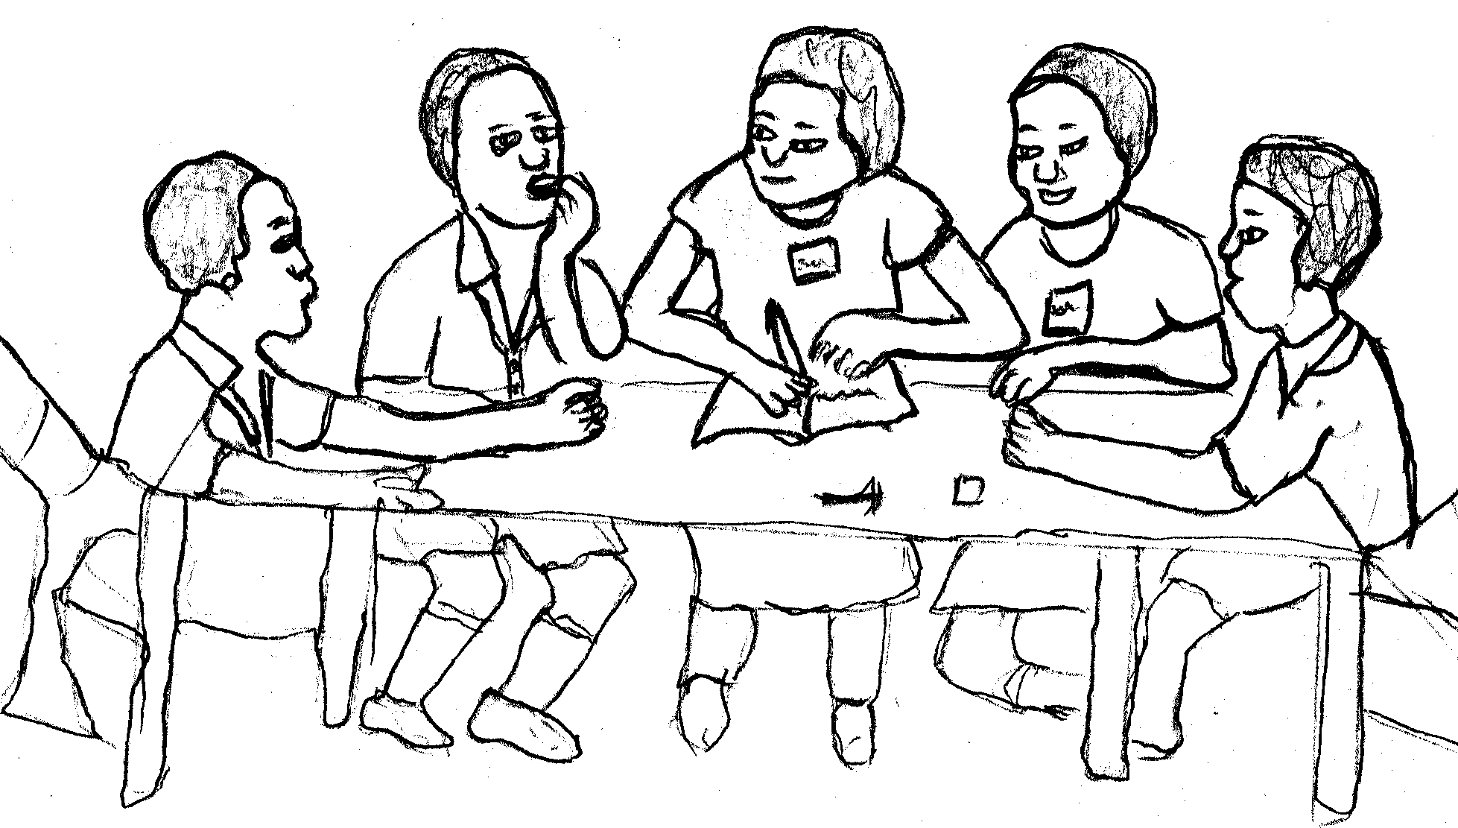
I. Nyikuta ma Dhopadhola

II. Riwo Nyikuta Aryo
III. Riwo Nyikuta Adek/Aŋwen
IV. Agecha gi Dwanyo Wach
- Jakwakirok jakun
- Makoko jye wok i tonge
- Ŋata kifwonji wotho gi gimoro yuŋeye
- Awendo ma lwor ama yindira
- Jagwondo Jarawanya
- Jafwoch ama yeŋ
- Jakisunga kilogi
- Theke theke aŋwech jodongo
- Muwolo loyo muŋwenyere
- Mwolo pa rombo kimon go dwiro
- Awendo kingoye gachiero
- Ŋaŋo meno thoyo
- Achiel achiel a wich (kosa kayego)
- Kuro kwo oloyo ŋaŋo
- Awendo timo ni che-
- Chandere aka i nolim
- Wot gwendi gore i chuŋ machon
- Kisalaka kiyengere nono
- Nyakus dhiaŋ kiwoki i kigo nono
- Ikiri chai bo ma dikado
- Jambaka nyewo mbiye
- Jamikwenda wiye bulero
- Kama olwokere ama kithwo iye
- Kichami gi rochi
- Chandi waŋ adhola
- Kisi ndelo kibedi sabit
- Koth goyo min gweno loko mbwoŋ
- Furi wire
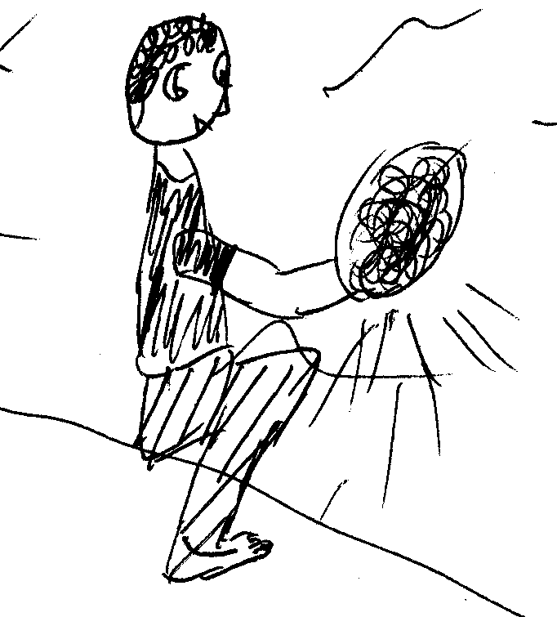
- Koth ma odiechieŋ kigoy ŋata achiel
- Koth ma ogoyin gi pe
- Kulo gi bemo
Gi: Athieno Getrude kod Nyafwono Connie

V. Dwanyo Lew
- Yiwi mamba miti, yiwi mamba miti
- Amudhe dicha chiemo dho ndelo dho loka dho jwom
- Waka waka wakawaka ni wakawaka
- Madhombedhombe patha patha ni patha patha
- Kwara kidho kudho gwara Gwaragwara
- Mwodo mwodo mwodere pa mwodo
- Ochola chor achero machon ma cheŋino Ochieŋ ochiemiye
- Ochola ocholo Achola chon
- Okello oleko lek yo loka koro
- Adhadha odhier g’adher i dhoyo
- Kwany kwer iwey kwinyo
Gi: Athieno Getrude Owor Obel Joyce kod Nyawere Magdalen

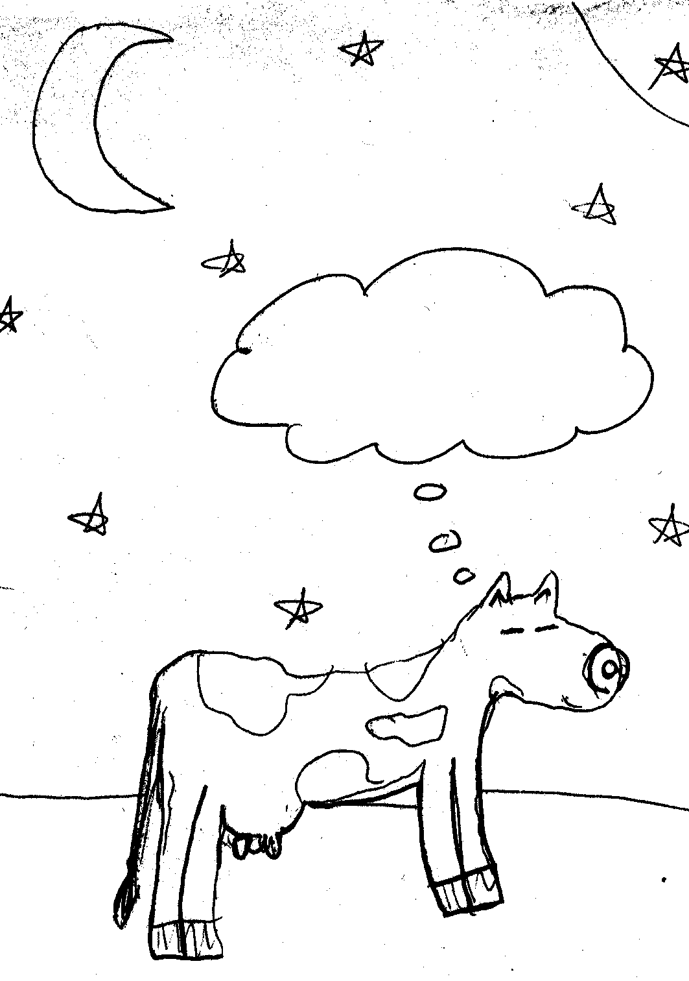
VI. Sikoiko
- Dhiaŋ ka nindo paro aŋo?
- Anitye gi gikipiny adek, kodhi rabwo, diel, gi ondiek. Atimi nedi aka atiŋ jo jye akal gi jo malawa? Aka ye paran tiŋo gimoro achiel achiel.
- Muchungwa ochiek mito afwona.
- Aŋo ma mwonyo yokin tineno?
- Opiyo otelo Odongo kimaki.
- Adhadha langa langa i pendi.
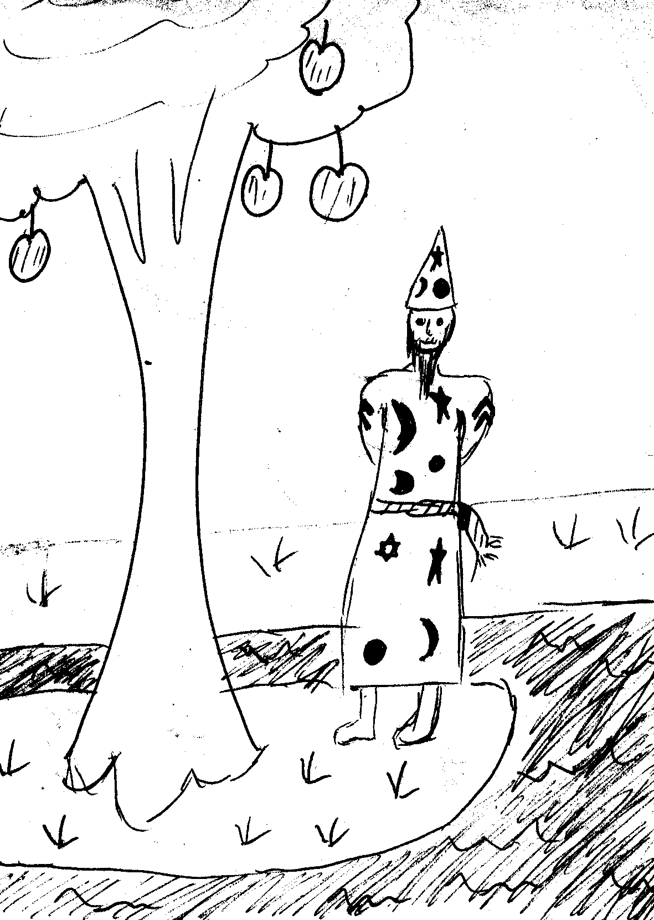
- Antiye gi muchungwa paran i dier malawa. Aka kenyo nitye jajwok. Atimi nedi aka acham muchungwa?
- Ageto ot paran ma ongoye dhu ot. Abedo aŋo?
- Nyathi paran okidho wendo ma ongoye gi nanga to dwoko gine. Abedo aŋo?
- Aŋo mofwonjo wan gi ruko kanzo?
- Gonyi diel iwey loch.
- Nya pa rwoth okedere.
- Adhadha otho oweyo kisiwiro.
- Nyir owaŋo wiy jo.
- Aŋo mofwonjo wan gi ruko junga?

Radwok ma Sikoiko
- Paro ni kama diel jye nitye gi yer tike aka an aŋata angoye gine.
- Teli tero diel loka, dwoki i omi ondiek bende iteri loka, to idwoko kod diel. Kwany kodhi rabwo bende iteri loka. Nyaka to i gik omo diel.
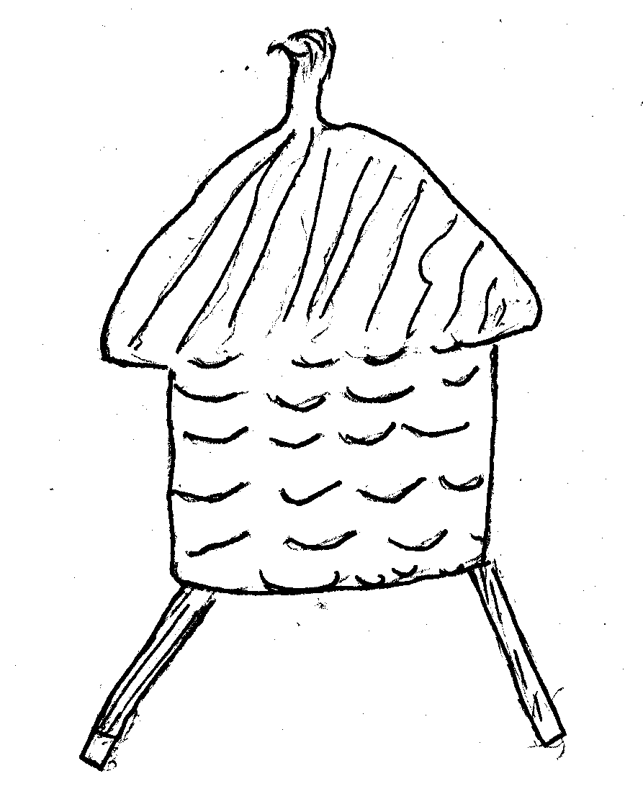
- Nyako othik mito poro
- Dero
- Tiendi gal
- Musalawuyo
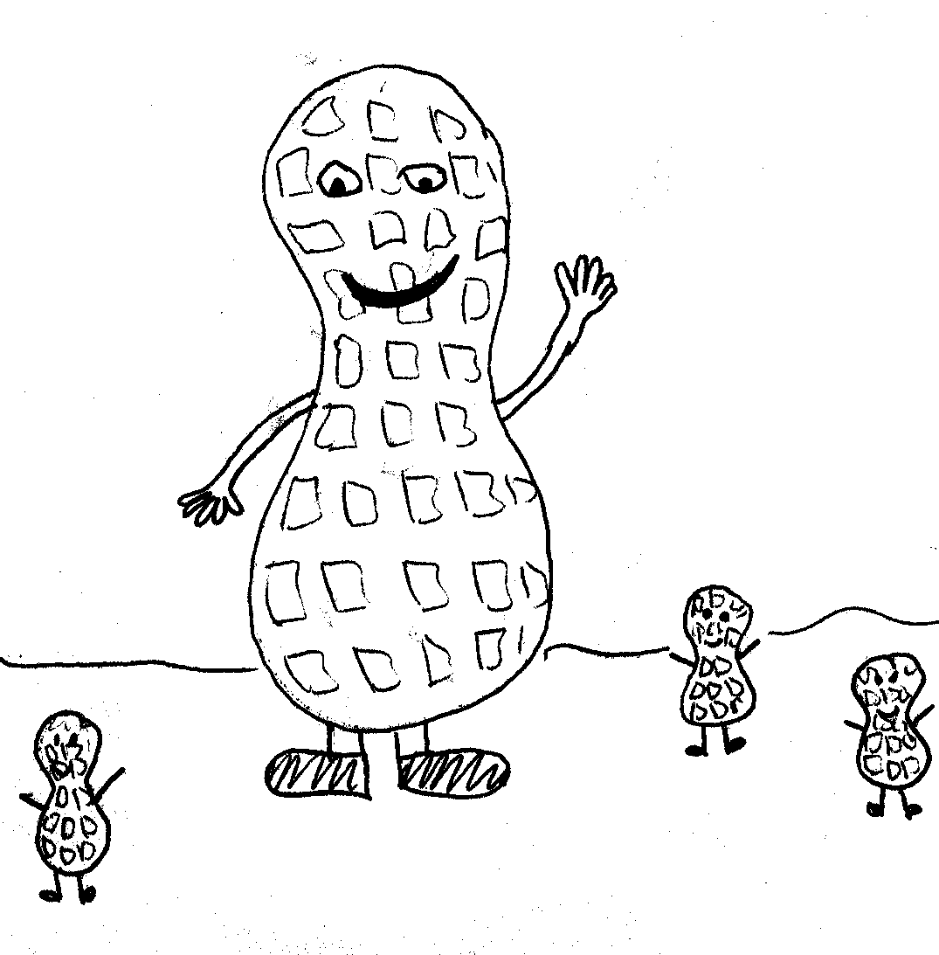
- Kwany tele idwiri gine jajwok aka jajwok wofwoni muchungwa to dwirin gine.
- Tongweno
- Maido
- Ŋwen
- Oseyo
- Nanasi
- Alemo oweyo royo
- Toko
- Obwol
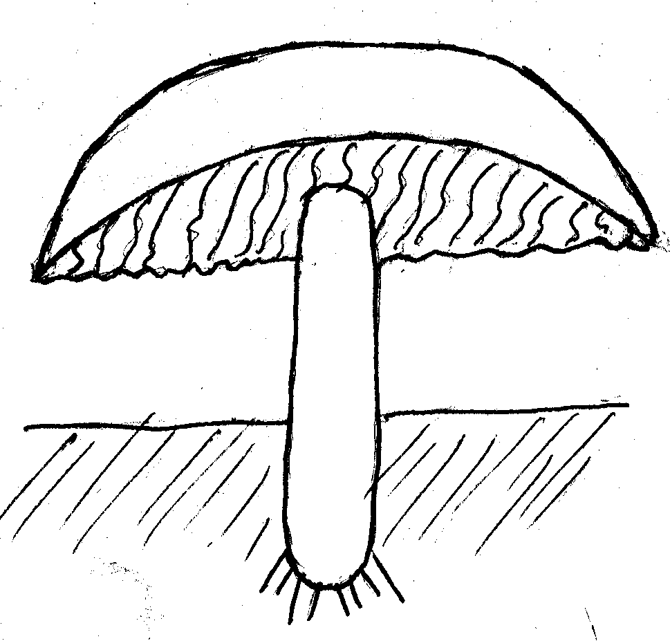
Gi: Nyaketcho Jane Irene Owino Joseph kod Nyadoi Immaculate

VII. Kigana

i. Gimumiyo Gwendi Lworo Otengo
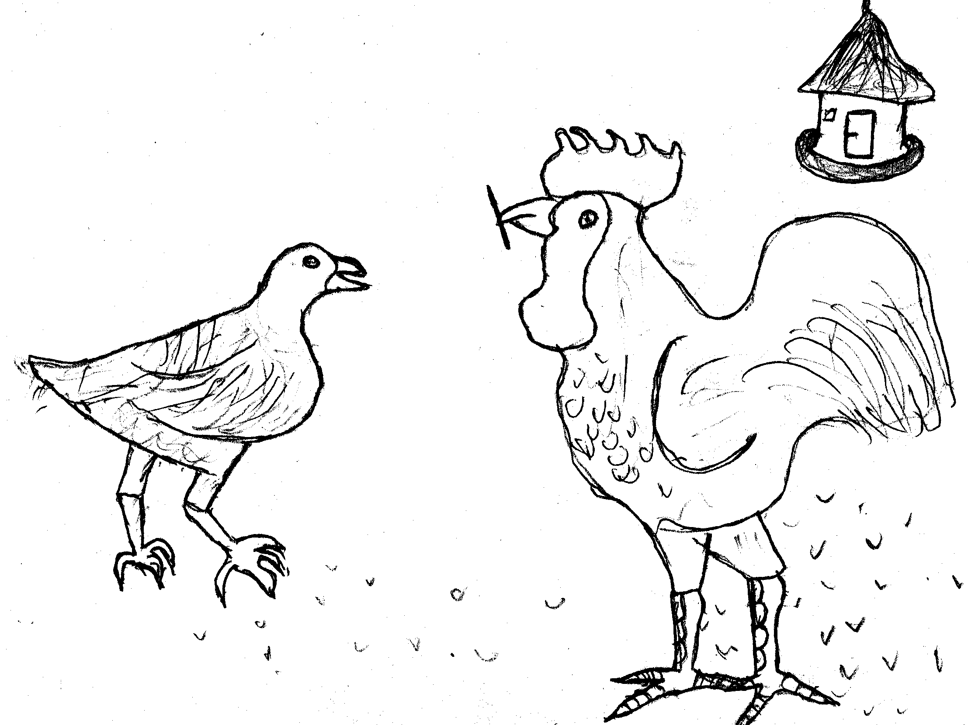
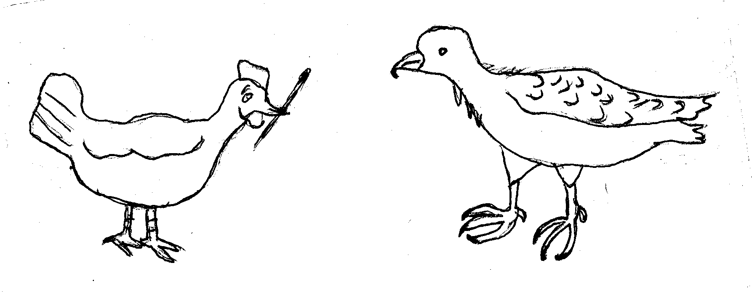
Chango chango, gweno jomako mere kod katateŋ. Mere pajo obedo matek swa ma kisi gimoro jye jo kwayere. Ndelo achiel gweno oayi to kidho pa otengo to kwayo go piso ma kwoyo nanga. Munyo gweno odwoko gi piso to kwoyo gine nanga. Munyo ochowo kwoyo nanga, to kano piso i ot. Otengo okuro ni gweno odwoki ri go piso pere to gweno kudwoko. Ndelo achiel otengo won otiŋere to kidho pa gweno penjo go piso pere. Gweno oayi to kidho kama chango no go okano i iye piso to kunwaŋo. Gweno oparo gima go owachi ri jawodhe to ngoye. Rumacheni gweno owacho ri otengo ni “Piso orwenyo ran kama aketho i iye. Weyi doko, alatemo rango, ka anwaŋo alakelo rin.” Gweno otemo atema yaro piny ni rango ri otengo piso pere to kwero nwaŋo kiri dikin.
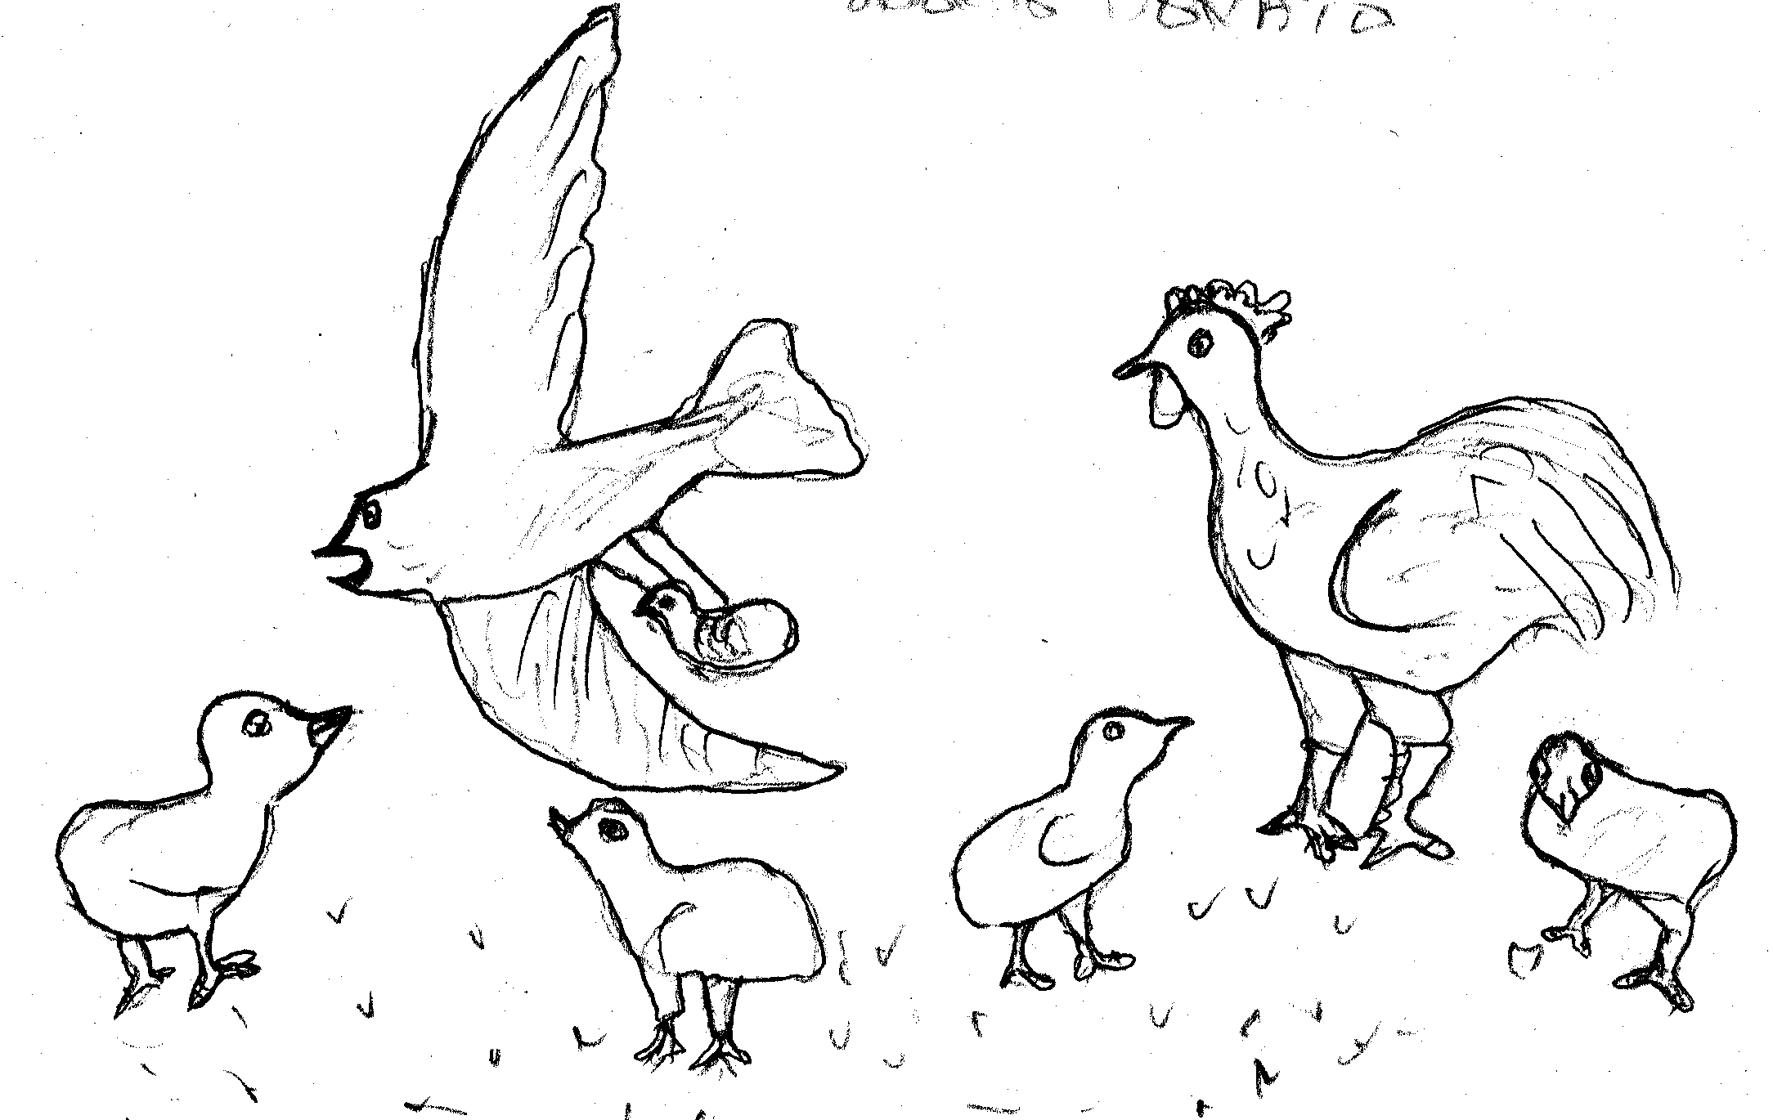
Woki ndelo no kiri konon mere pa gweno kod otengo tu tho atha. Meno amomiyo ineno gweno yaro piny munyo rango ri otengo piso pere. Aka bende amomiyo otengo chamo nyithindhi gwendi ri piso pere ma gweno orwenyo.

Gi: Nyafwono Connie
ii. Lwaŋino gi Awino

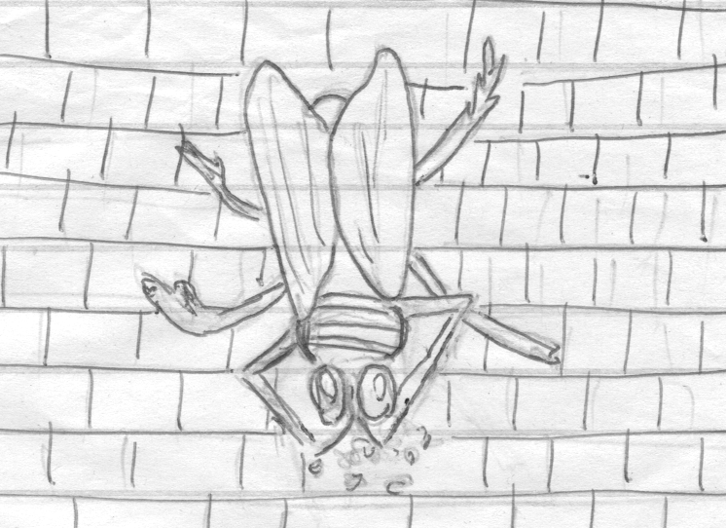
Obedo ndelo achiel Awino okidho i sikul, to neno lwaŋino. Lwaŋino oido opie i kor ot ma sikul.
To lwaŋino penjo go ni, “Ikidho i kilas perin?”
To godwoko, “Eei akidho i kilas.”
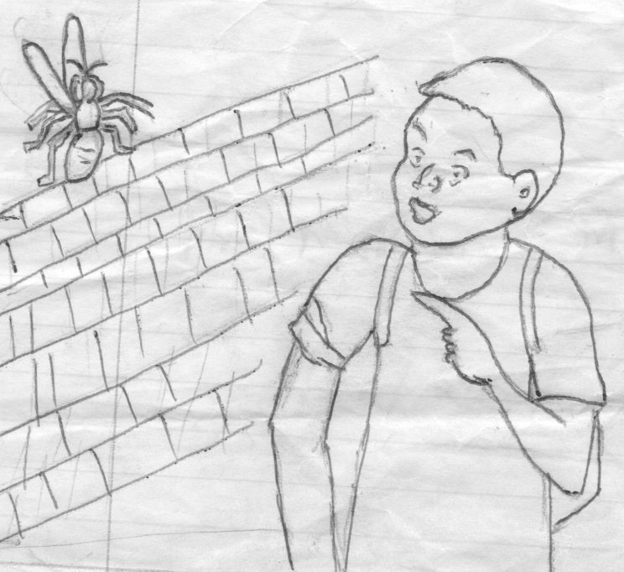
To lwaŋino wacho ni “Kale, abende, akidho i kilas.” Lwaŋino omedo luwo ni, “Awino, kidonjo i kilas. Ikiri nenan; ikiri luwi; ikiri nur. To neni anena kitabo perin.”
Munyo gosoma kitabo pere i sikul, to goneno lwaŋino i kor ot.
To godiyo nyawote ma bedo gine i kom to wacho ri go ni, “Neni lwaŋino no, goluwo.”
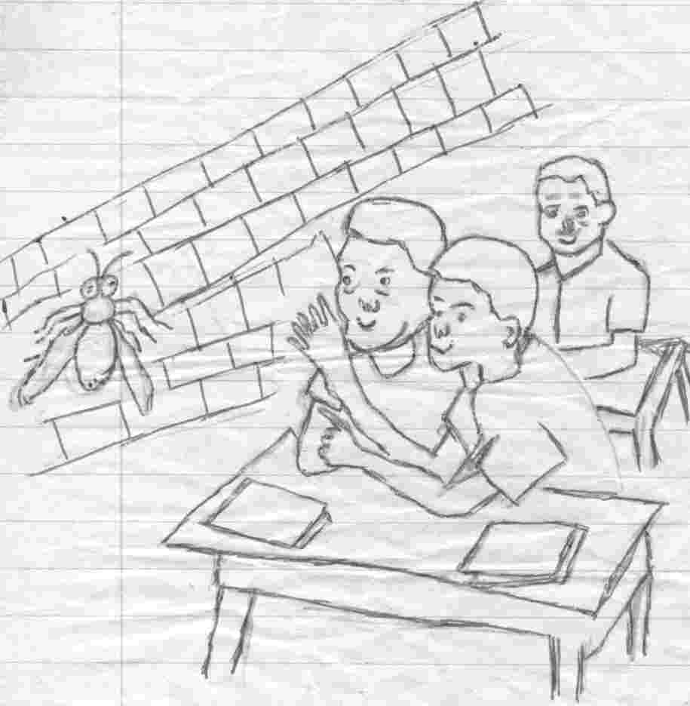
To dichiel lwaŋino to pie i waŋe, to nyutho jafwonji pere. Munyo wacho ni, “Lwaŋino ni waŋan, jafwonji konyan, ikwanyi ran!”
Jafwonji to konjo pi i kikopo to wacho ni, “Yawi waŋin.” To lwoko waŋe to lwaŋino wok i waŋe to ayi to kadho.
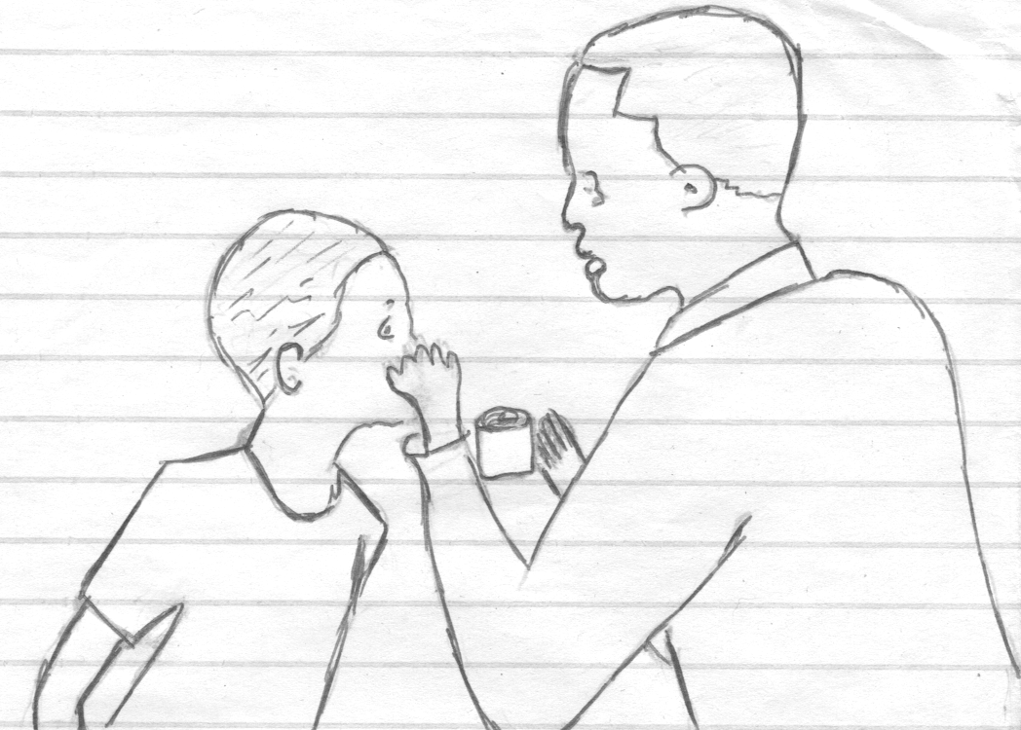
To ayi to pie i dirisa to bedo iwi dirisa to lwoko waŋe gi tiende.

Gi: Okech Michael kod Ochwo Wilbrod
iii. Pusi kod Oyeyo
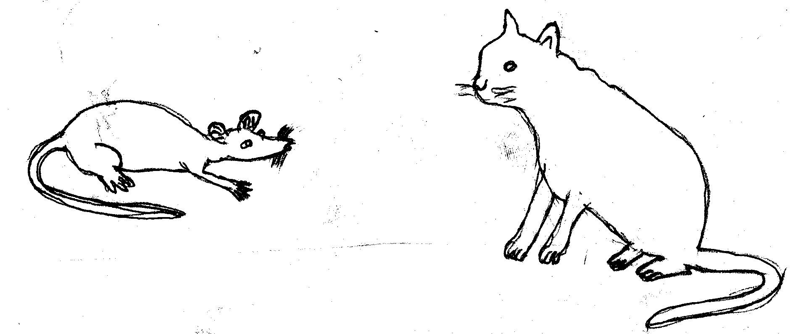
Chango chango, obedo Pusi kod Oyeyo to jomakere mere.
Pusi kod Oyeyo jonyewo modhiaŋ pajo to joketho i dak to joŋawo kisalaka.
Ndelo achiel Pusi oromo kod Oyeyo to penjo go ni “Ojame, iwok yukune?”
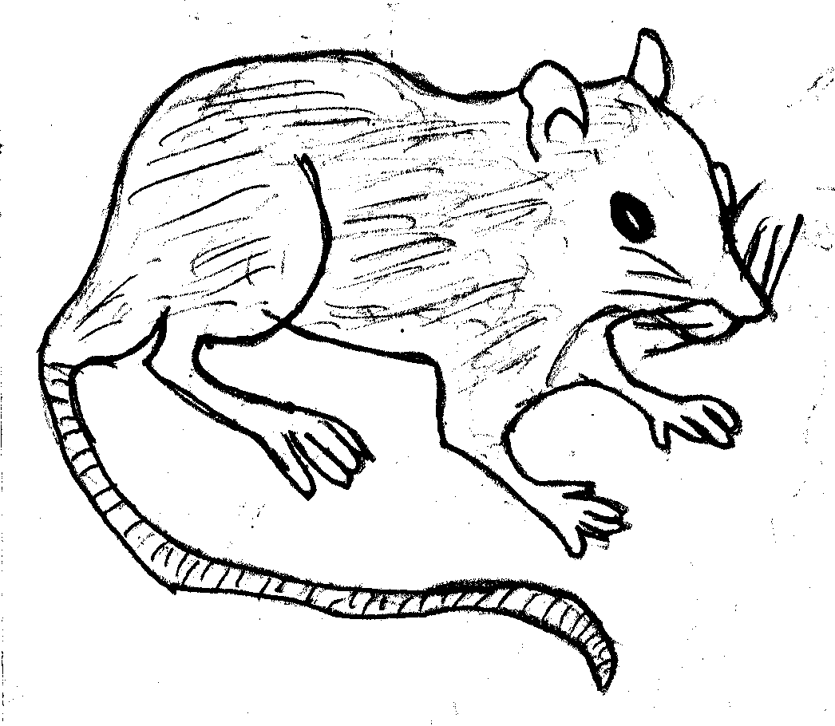
Oyeyo owacho rigo ni “Awok kibatisa nyathi paran.”
Pusi openjo go ni “Ibatisa go ni ŋa?”
Oyeyo odwoko ni “Abatisa go ni Onaŋo-de-onaŋo-de-oweyo-i-ganga.”
Ndelo man doko Pusi oromo kod Oyeyo to penjo go ni “Ojame, iwok yukune?”
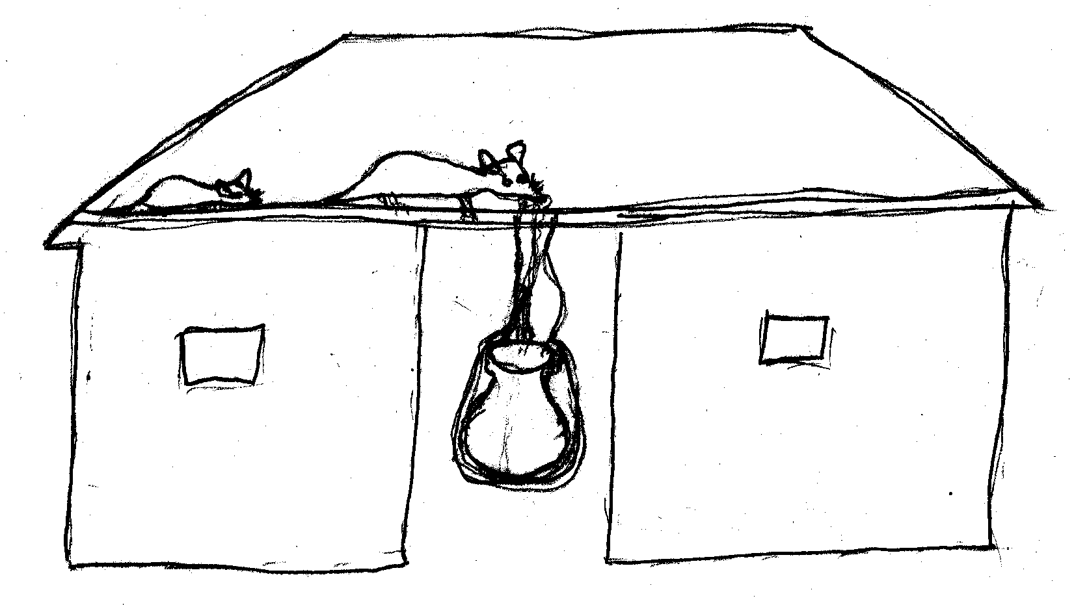
Oyeyo odwoko ni “Awok kibatisa nyathi paran.”
Pusi openjo ni “Ibatisa go ni ŋa?”
Oyeyo odwoko go ni “Abatisa go ni Onaŋo-de-onaŋo-de-oweyo-i-kore.”
Ndelo man doko Pusi oromo kod Oyeyo to penjo go ni “Ojame, iwok yukune?”
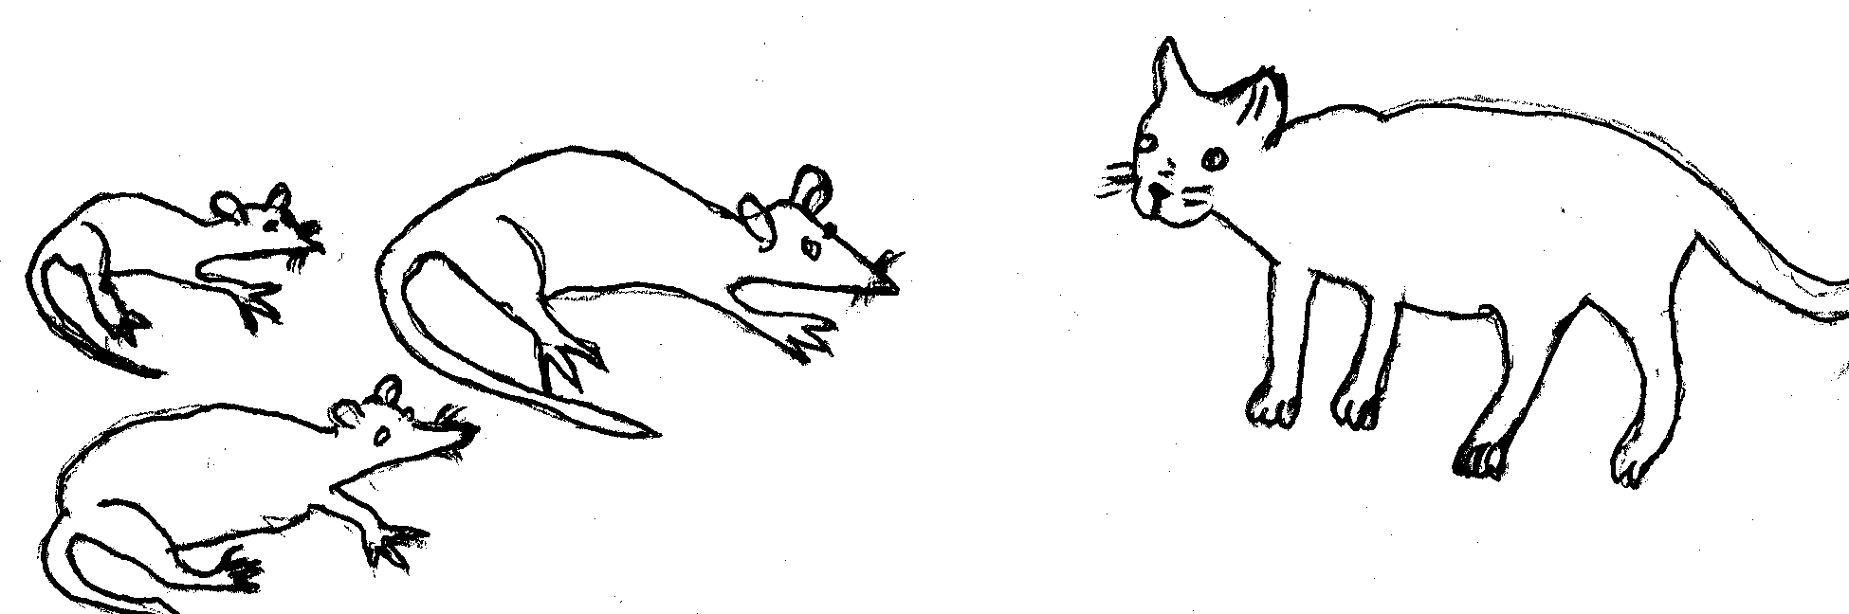
Oyeyo odwoko go ni “Awok kibatisa nyathi paran.”
Pusi openjo ni “Ibatisa go ni ŋa?”
Oyeyo odwoko ni “Abatisa go ni Onaŋo de onaŋo de olwindo.”
Ndelo achiel Pusi owacho ri Oyeyo ni “Wakidhi walimi mo mawan.” Oyeyo oayi to pondo ri Pusi. Pusi won to ayi kidho limo mo kama ndelago jokano iye. Munyo Pusi otundo onwaŋo anwaŋa dak nono. Mo ongoye iye kada nyaka mathin. Pusi odok to kidho rango Oyeyo wacho rigo paka mo ma chango jokano i dak ongoye kada nyaka mathin. Munyo Oyeyo oneno Pusi obino, Oyeyo oringo to pondo. Pusi owacho ni “Iraŋo Oyeyo onenan to pondo? Nyutho ni go ama onaŋo mo ma wakano.”
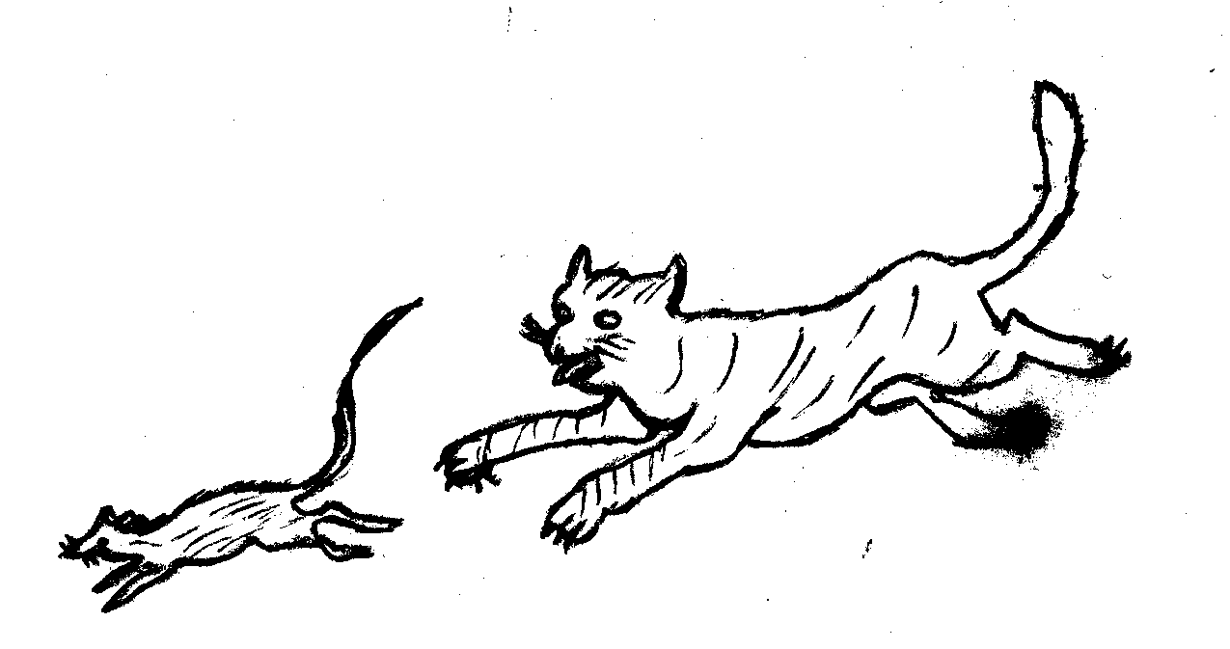
Wok ndelo no Pusi kuneno Oyeyo to neko aneka to chamo. Oyeyo bende koneno Pusi ringo aringa to pondo munyo lworo Pusi.

Gi: Nyafwono Connie
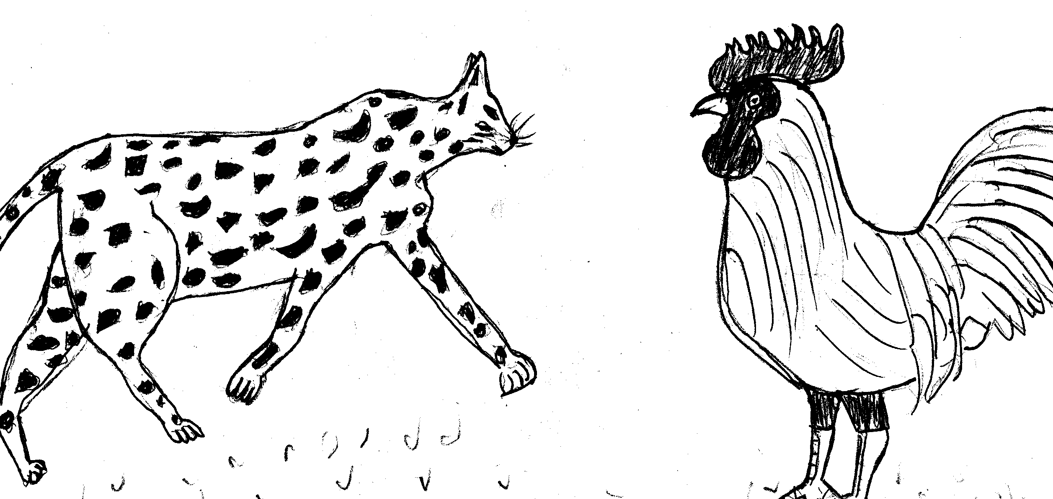
iv. Kwach gi Gweno
Chango chango, gwendi gi ogwaŋe jobedo mere swa tek tek. Gwendi gi ogwaŋe jo jye oido jobedo, jochiemo, jonindo i dudi. To dichiel kwach omito tedo ri nyithindhe chiemo to mach ongoye.
To kwach poyo dichiel paka joliesa gi wod gweno kwoŋ gima mako mach. Wod gweno to wacho ri kwach ni, “I wiyan, gimi neno mobokere no, meno mach.”
To kwach kidho pa wod gweno kwayo mach tedo ri nyithindhe. To munyo kwach okidho to nwaŋo wod gweno ongoye tichiko, godwoko othieno. Munyo kwach odoko ogik mararyo, kareno chieŋ liel swa. To wod gweno wacho ni, “Mach me lieth swa kimoko gi sawa me. Wiyan yaliel kir in bende iyaliel. Amomiyo idwoki othieno ka piny okwe.” To doko kwach dok.
To kwach dok, kuro kir othieno munyo piny okwe to doko gik. Maradek to nwaŋo wod gweno munyo nindo. To temo chiewo go, to wod gweno konyalo chiewi.
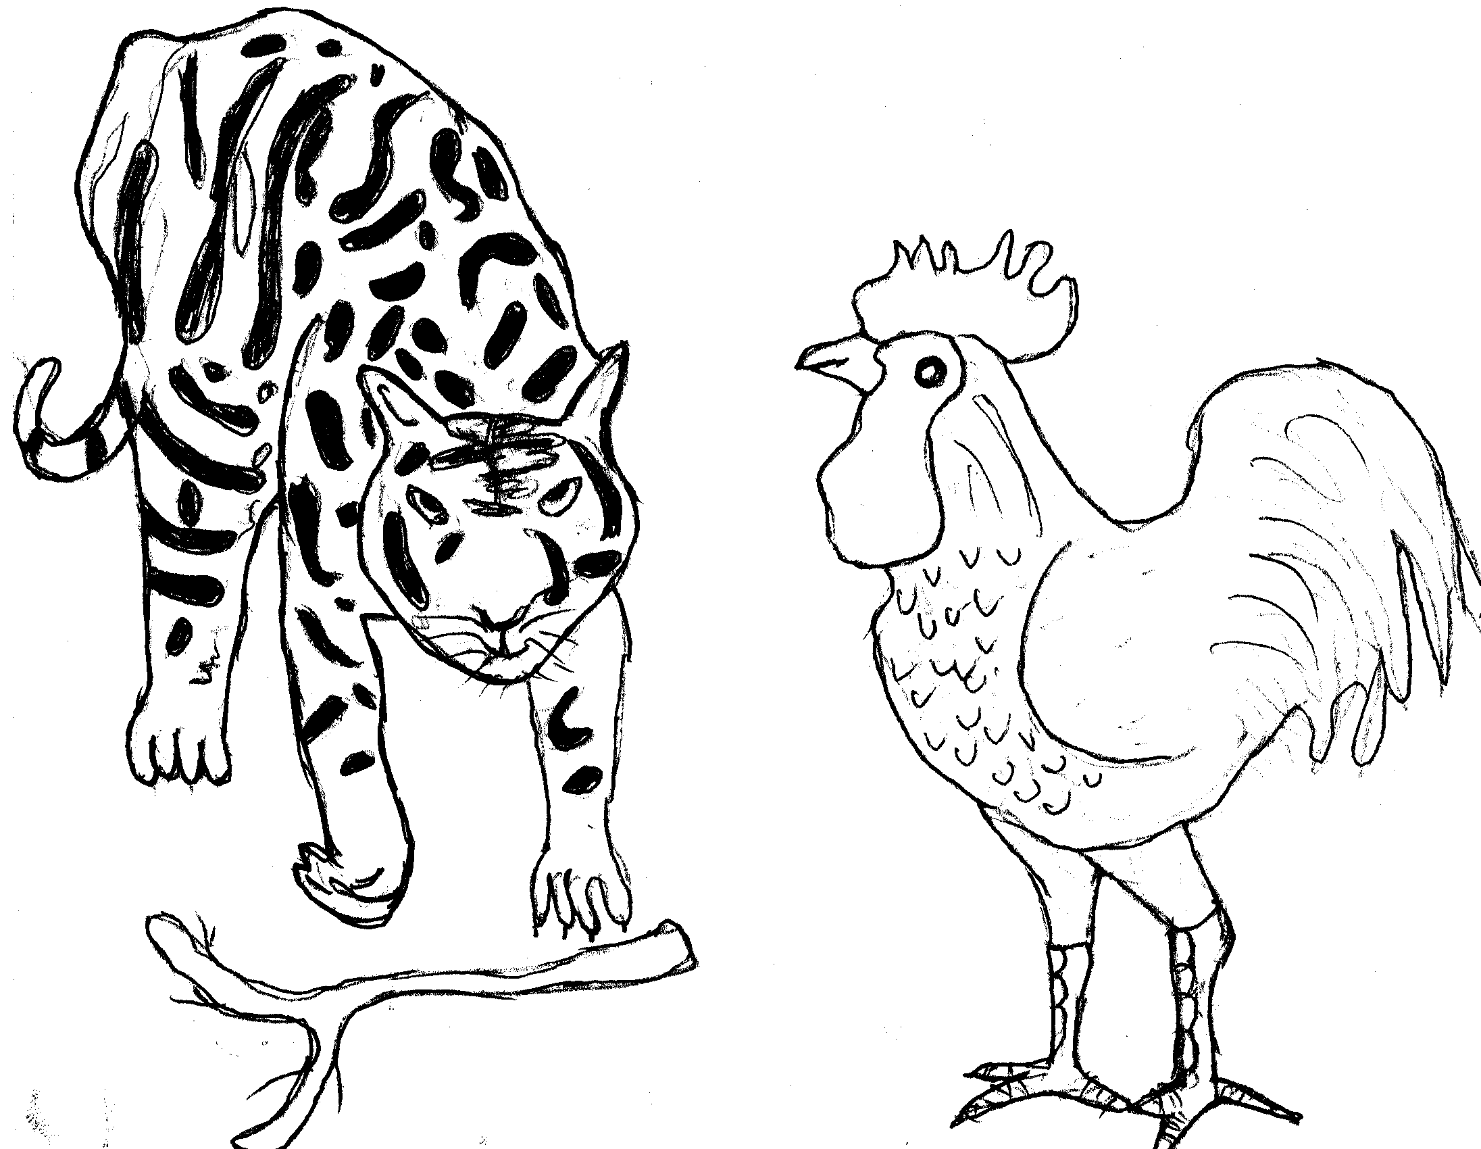
To kenyo paro bino ri kwach ma kwalo mach. To dimo lum mothwo swa ma nyalo moko piyo piyo. To choko, munyo otieko choko to tiŋo. Okidho kama wod gweno nindo iye. Munyo otundo to ketho lum i wiye wod gweno mach komoko. Mararyo to doko ketho mach doko koliel. Maradek kwach rume to ruda aruda lum i kokoliro wod gweno jye doko mach koliel.
Gi: Okoth Mariko
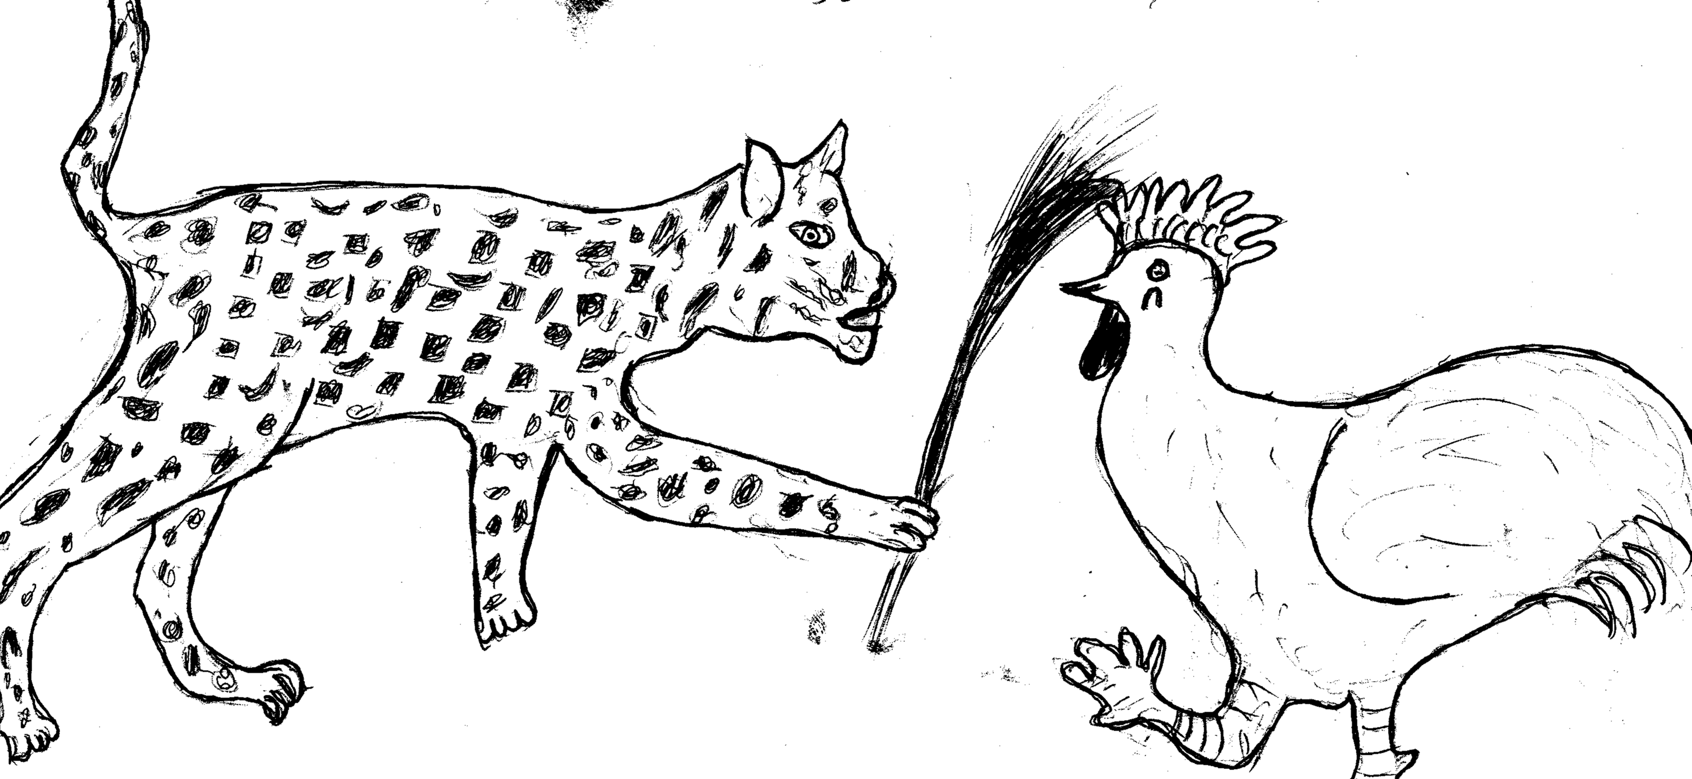
To wod gweno chiewi. To neno kwach, obedo chiegin bothi. To wacho ri kwach ni, “Ikiri chore chiegin. Ayawaŋin gi mach ma wiyan.” To yengo wiye munyo bwoko kwach paka lawaŋo go.
Kwach koringo kosa kodhire gi chien. To kwach wacho ri wod gweno ni, “Gima ni wiyin no, kimach, itwodo.”
Gi kenyo to kwach lokere ri wod gweno mager. To mito kiri mako wod gweno oneki ri twodo pere. To wod gweno wire gi ŋwech munyo koko ri gwendi wadi jye ni “Kok kok kudee!”(loki Dhopadhola ‘Kawagalo kadagala, ilaneko wan!’) To joŋwecho gi ŋwech madit swa.
Wok ndir no gwendi joringo wok i dudi kama oido jobedo iye. Kiri gonyo gwendi bedo bothi ji. Wor jonindo i ot munyo jolworo ogwange.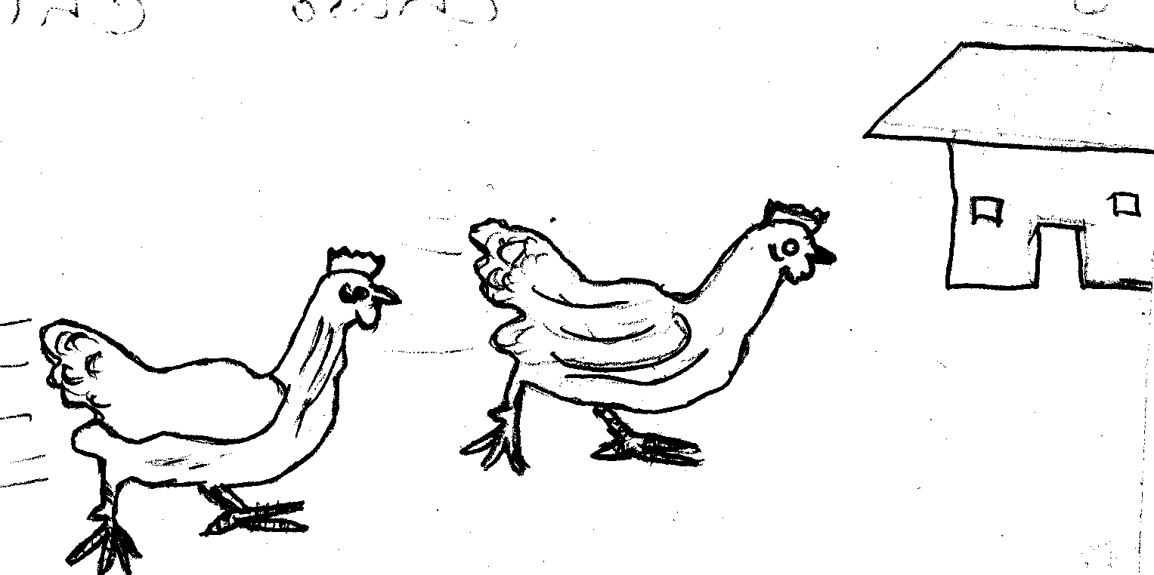

Gi: Okech Michael kod Ochwo Wilbrod
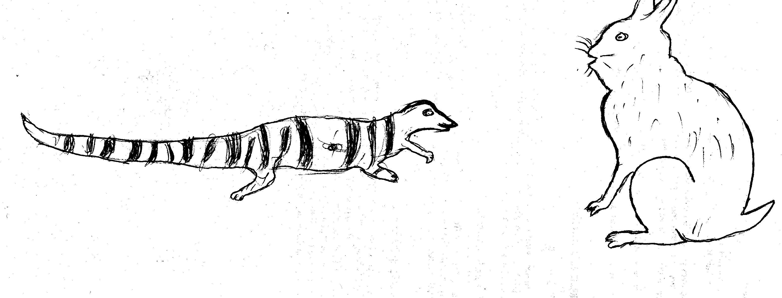
v. Ochulu gi Ŋech
Kigana pa Ochulu gi Ŋech (gimumiyo Ŋech nindo i kero).
Chango chango, obedo Ochulu gi Ŋech to jomako mere.
Ndelo achiel to Ŋech wacho ri Ochulu ni okwaŋi go wendo pa ore.
Ochulu bende to yeyo. Munyo ndelo otundo to joayi kadho wendo. Munyo jonitye i royo Ochulu ochungo to wacho ri mere pere ni, “Paka wakidho pa or wakiri waor nyingi wan ma kisindelo. Wachwok nyingi wan man ma olwoŋi gine wan.” Ŋech bende kokwero.
Ochulu to wacho ri Ŋech oteli yero nyinge. Ŋech to yero nyinge ni ‘Jadwong’ to Ochulu to yero nyinge ni ‘Wendo.’
Munyo jotundo pa or Ŋech, ti fwoyo gi neno jo swa. Munyo jopecho jowacho ni, “Wafwoyo swa gi neno wendo.”
Ochulu to wacho ri Ŋech, “Ofwoyi gi nenan kendan.”
To won pecho doko wacho ni, “Keli win ri wendo kom.”
Ochulu to wacho ni, “Meno jye kom paran.”
Doko ti wacho ni, “Keli win ri wendo koŋo.”
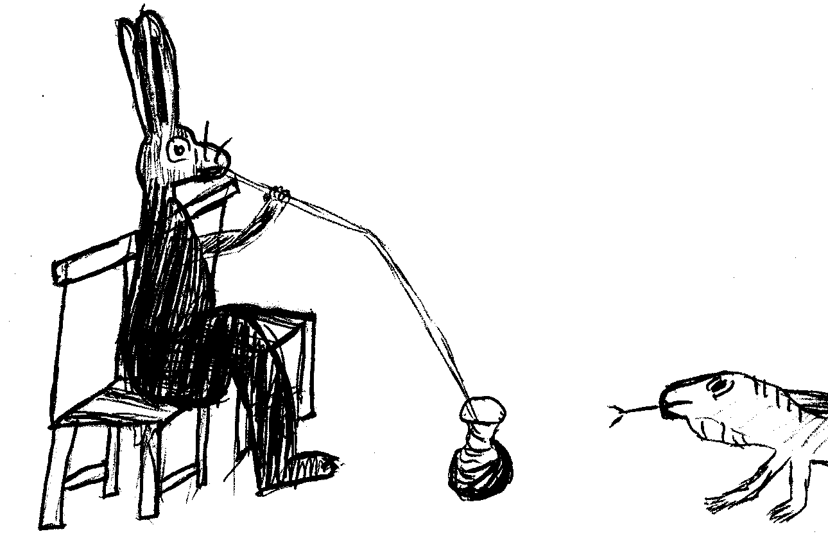
Ochulu to wacho ni, “Meno jye koŋo paran.” to madho woko jye kende.
To i kelo chiemo kareno Ŋech kech neko go tek tek swa. To jokidho logo woko, munyo jodwoko chiemo chingi Ŋech oido koch paka go patho apatha i lowo. Ochulu to wacho ri go ni “Ojame neni chingin paka koch. Ikiri i kwo ti wiyan pa or, kidhi doko ilogi.” To Ŋech kidho logo kareno mere pere Ochulu chiemo swa piyo piyo.
Munyo Ŋech odwoko i dhuweri odoko chinge onwaŋo opoŋ iye lowo rupir gowotho gi chinge. Odoko Ochulu wacho ri go ni ogik ologi. Munyo odwoko onwaŋo Ochulu ochowo chamo woko chiemo jye. Ma Odoŋi jye orwako i mugowa(kikapo) pere. Ochulu to lwoŋo, “Wegi pecho omo sendere.” To josewila jo to jodok ma nyawote kochiemo.
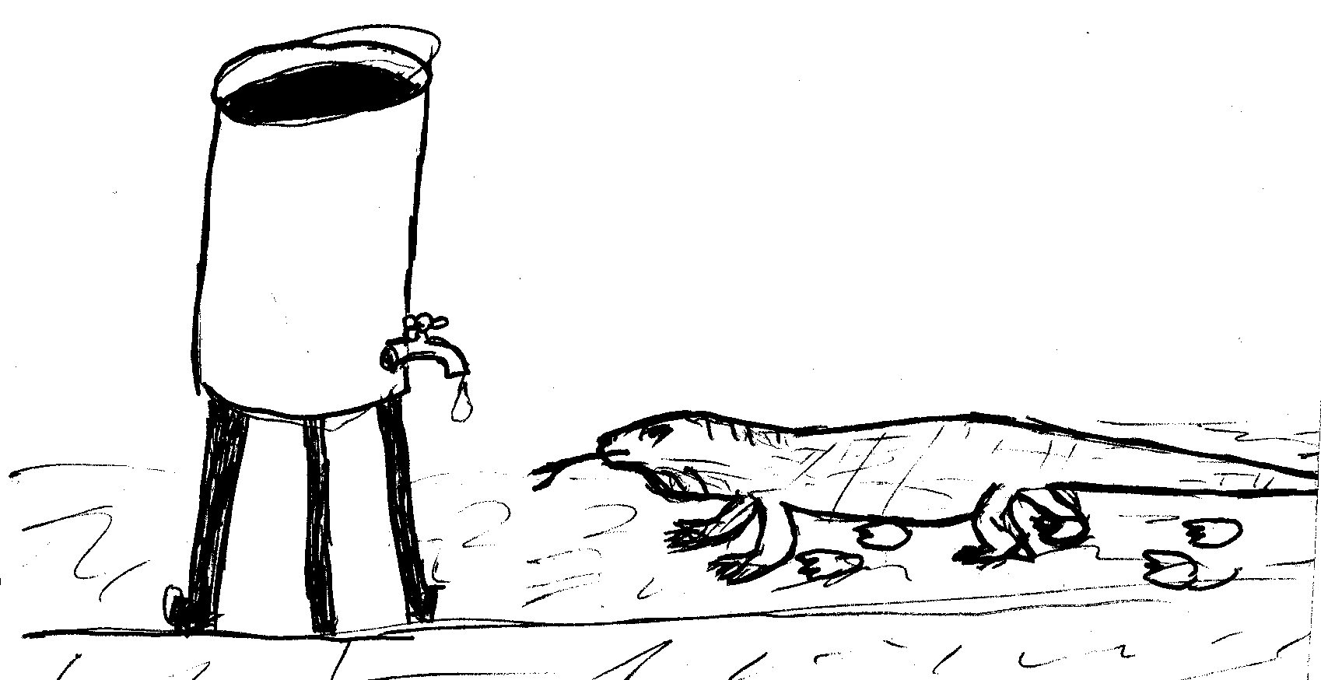
Munyo jotundo i royo to Ŋech gak i dudi ni iye riemo, to ŋwecho yo wiyi Ochulu to lokere simon. Ochulu munyo otundo kama di simon to gweyo munyo wacho ni, “Me Ŋech won ama rendere.” To Ŋech doko ŋwecho aŋwecha malo kama chipa Ochulu ofuro iye to lokere ombokoro. Munyo Ochulu otundo i ndelo to neno ombokoro, okwako dimo to ketho i mugowa pere ka wacho ni, “Min Awoi me miŋi swa oweyo ombokoyo pa nyathi payan i ndeyo ka.”
Munyo otundo pecho owacho ri min Awor konjo woko fufa ma nwaŋo otedo. To oro Awor omo mugowa ma nende odwoko gine. Awor otemo tiŋo mugowa to wacho ni mugowa pek swa. To Ochulu wacho ri dhako pere min Awor kidho omo mugowa. Dhako pere bende konyalo tiŋo mugowa.
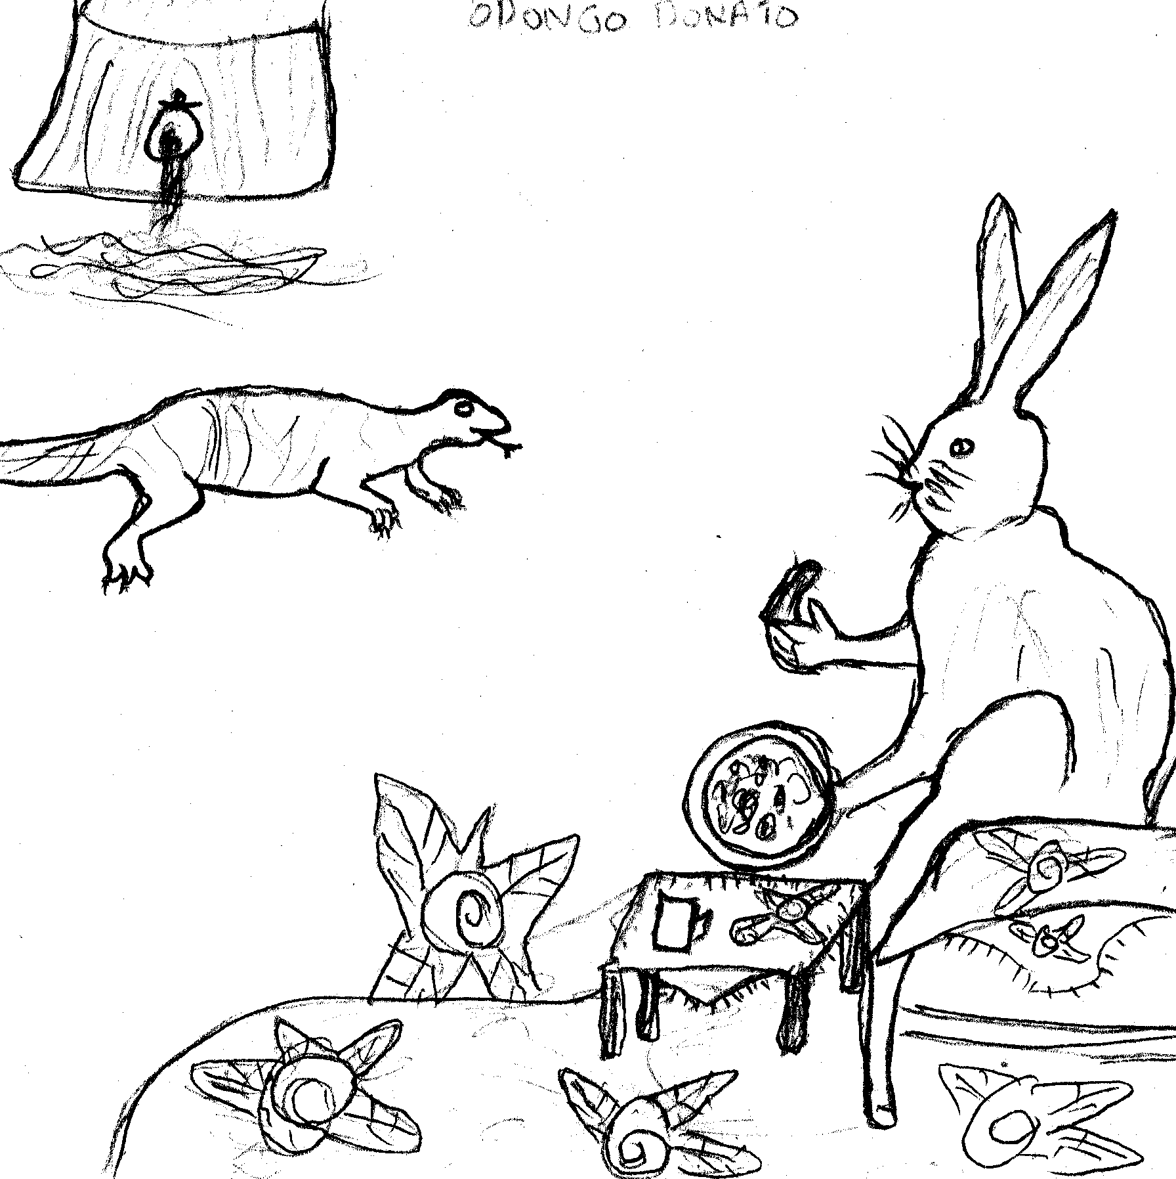
To gowon kidho. Onwaŋo mugowa pek swa, to tiŋo gi meni to wodho i diedipo. Munyo oyawo mugowa to Ŋech woki gi ŋwechi. To Ochulu joriemo swa tek tek to Ŋech ŋwecho to yombo jo to donjo i kero.
Amomiyo pama Ŋech bwoki paro ni Ochulu fwodi riemo go. Ŋech ŋwecho to donjo i kero.

Gi: Owor Moses Jambaka kod Nyadoi Evaline Mijasi
vi. Merin Adek

Chango chango, obedo Wakafundo, Alur, kod Kagujuguju. Jobedo merin matek.
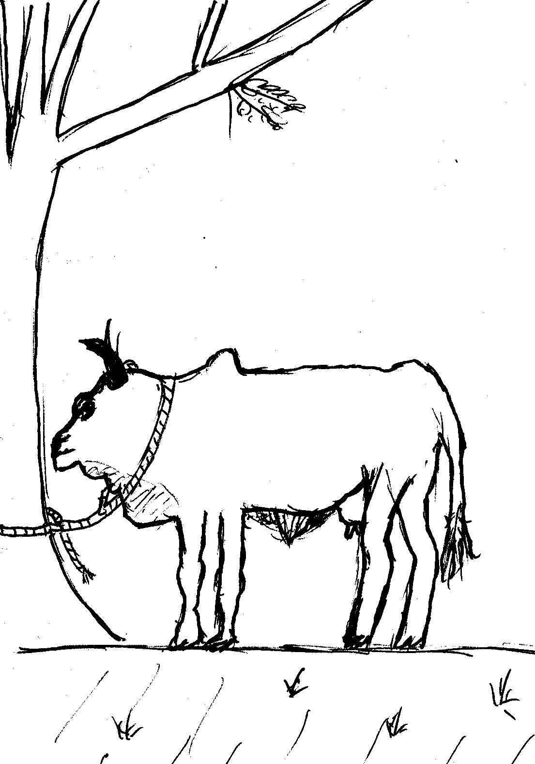
Ndelo achiel Wakafundo, Alur kod Kogujuguju joayi to jokidho i katale nyewo dhiaŋ. Munyo jotieko nyewo dhiaŋ pajo to joayi dwoko, koth madwoŋ to chako chwe. Merin adek me to jotweyo dhiaŋ pajo i tiendi yath dho thengi ngudo to jokidho bwok koth i pecho machegin.
Munyo koth ochok jokidho i tiendi yath ma nende jotweyo iye dhiaŋ pajo jo wo chaki woth pajo to jokunwaŋo dhiaŋ. Jodwaro dhiaŋ kisi kamoro jye to jokunwaŋo. Jokwo ido jotieko kwalo woko dhiaŋ chon.
Wok ndelo no merin adek me jokedho chikirok pajo ama:
Wakafundo okwoŋere ni doko gokibino neno malo (polo) kama koth owoki iye ma omiyo dhiaŋ pajo okwali. Kir konon me Wakafundo kineni malo. Koneno malo, latho atha.
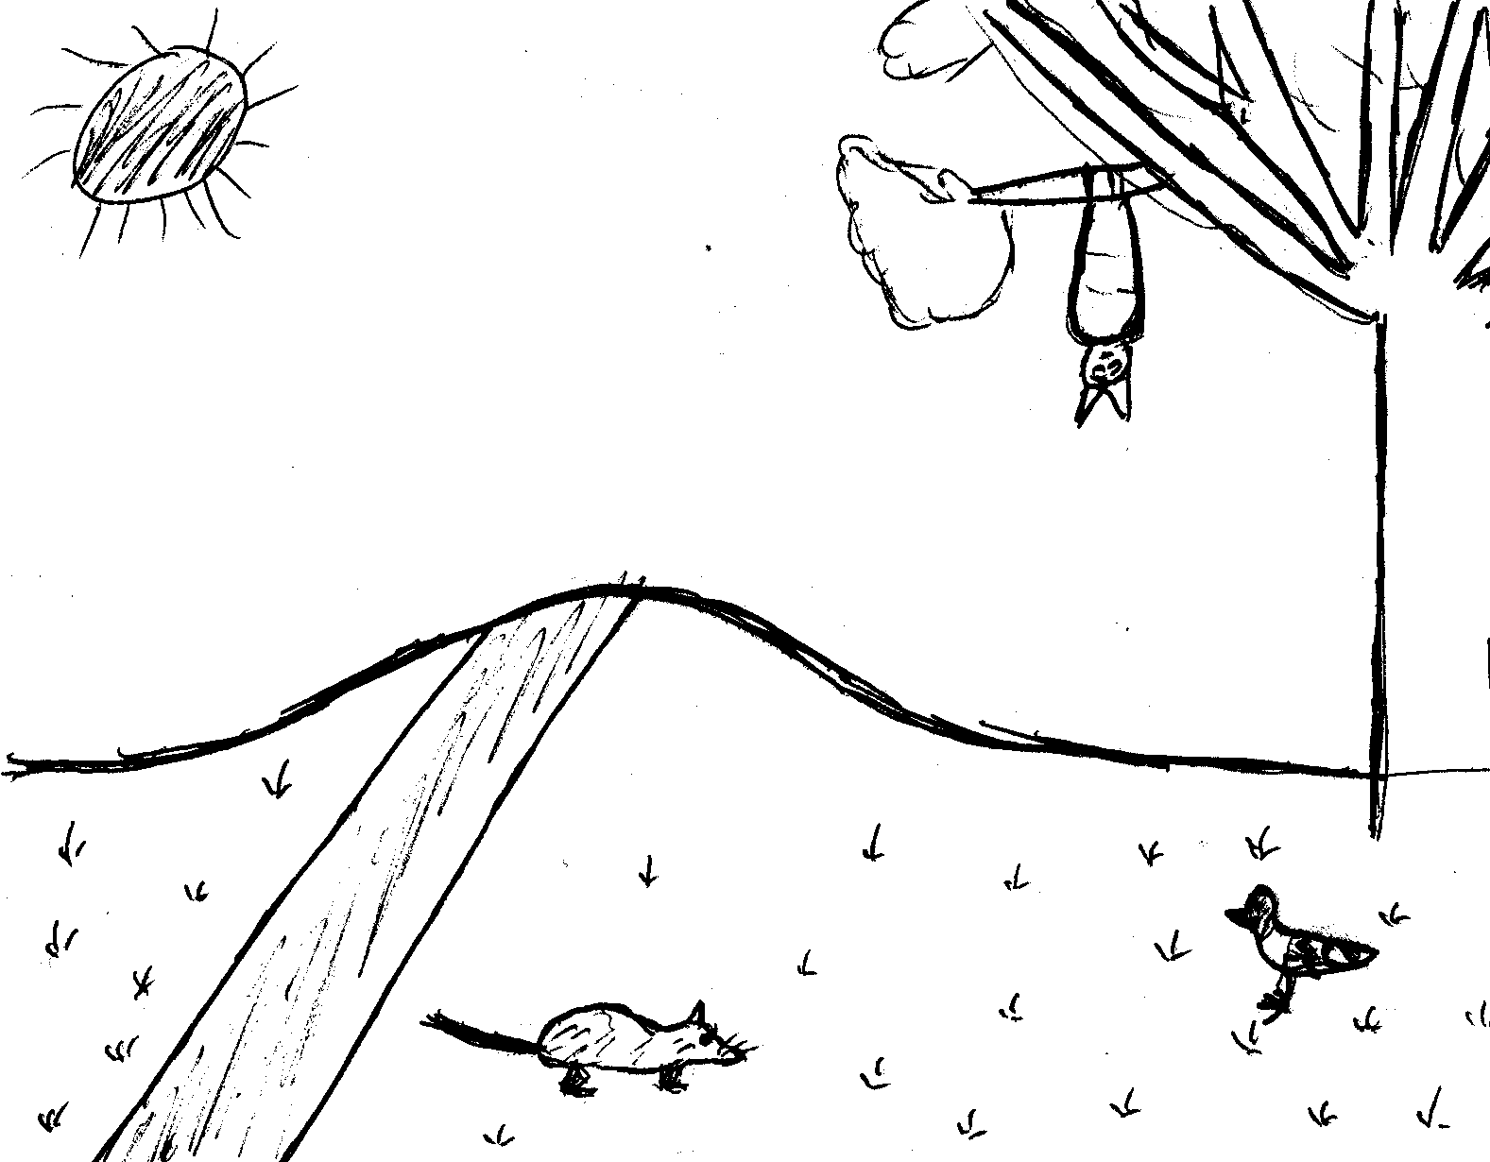
Alur okwoŋere ni doko gokibino piye wi yath ma oido jotweyo iye dhiaŋ pajo aka omiyo jokwo jokwalo.
Kagujuguju okwoŋere ni doko gokibino ŋado royo ma jo joluwo munyo jowok i katale.
Ka achiel kwoŋ jo otimo gino latho atha gi kenyo.

Gi: Emerikwa Michael
Oloki gi: Nyafwono Connie
vii. Jadwar

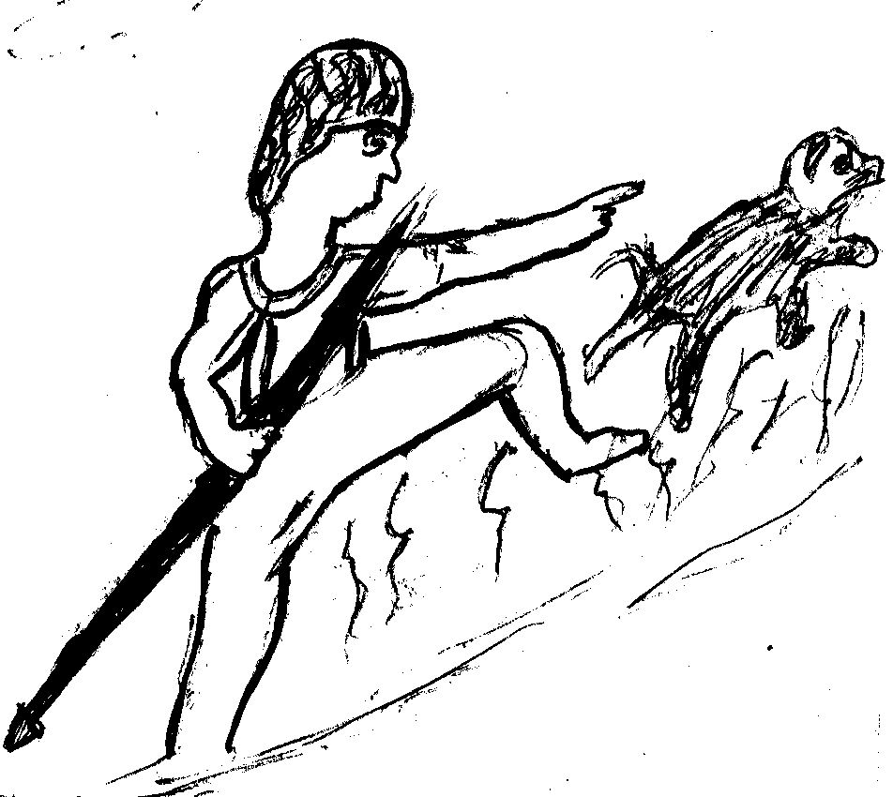
Chango chango, obedo jalmoro gi pecho pere.
Jalo obedo jadwar. Ndelo acheil owacho ri dhako pere gi nyithindho ni jokidhi jodoyi mwogo. Go to kidho dwar.
Dhako bende oayi gi nyithindho kadho doyo mwogo. I ndelo mwogo no nitye winyo ma chiemo i iye.
Dhako no gi nyithindho pere jodoyo mwogo to jochowo woko ndelo. Munyo winyo me obino chiemo onwaŋo ndelo ler. Winyo me to chako wer:
“Dhako me, dhako me
Imiyan girachula
Abende abino miyin girachula
Prii prii”
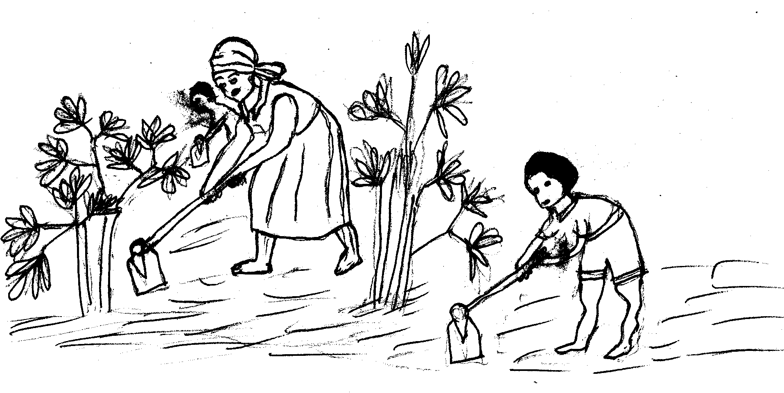
Munyo gowero ameno to diewo i ndelo to lum doko twi pa gen nende kenyo kufuri. To gochiemo rigin to yeŋ.
Munyo jadwoŋ me odwoko dwar to kidho neno muga ma nende dhako pere gi nyithindho jofuro. To nwaŋo ndelo oyukino ma ongoye kada lakikwer achiel ma otoŋ.
Jadwoŋ me odwoko to penjo dhako pere muga. Dhako owacho rigo ni, “Nende wadoyo adoyo mwogo jye to wachowo.”
Jadwoŋ me owacho rigo ni, “Ongoye kacha, kada lakikwer ma otoŋ, kada achiel.”
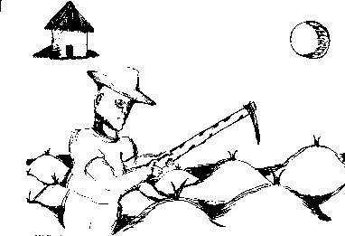
Yaweremere jadwoŋ me doko odhiro dhako me gi nyithindho kidho doyo mwogo. Jome jodoyo mwogo doko to jochowo.
Munyo winyo me obino to nwaŋo ndelo ler doko to chako wer.
“Dhako me, Dhako me
Imiyan girachula
Abende abino miyin girachula
Prii prii”
Doko to lum twi i ndelo gipi.
Munyo jadwoŋ me odwoko dwar to kidho i ndelo neno muga to nwaŋo ni ongoye kama ofuri, kada achiel. Ka godok penjo dhako to dhako wacho rigo paka jofuro afura ndelo jye.
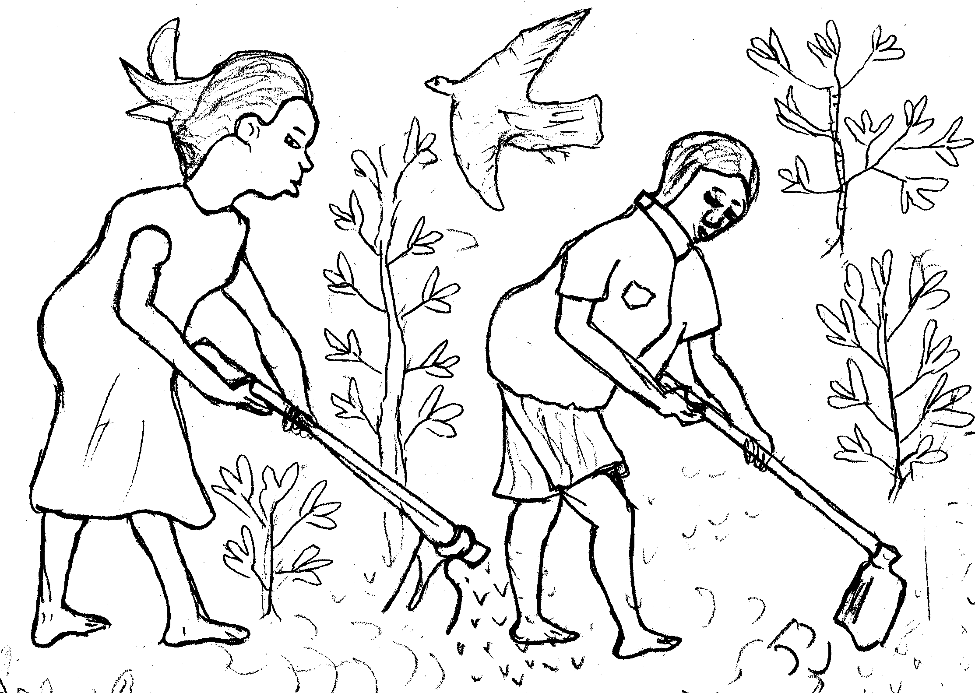
Ndelo maradek jadwoŋ me oayi gi dhako pere gi nyithindho jye to jokidho i ndelo to go bende jye temo furi to weyo munyo dhako gi nyithindho medere gi fur to go kadho dwar. Jome jofuro, to jochowo ndelo, to jodoki.
Winyo me doko obino to nwaŋo ndelo ler to doko wero ni:
“Dhako me, dhako me
Imiyan girachula
Abende abino miyin girachula
Prii prii”
To dudi twi to gochiemo to yeŋ to kadho.
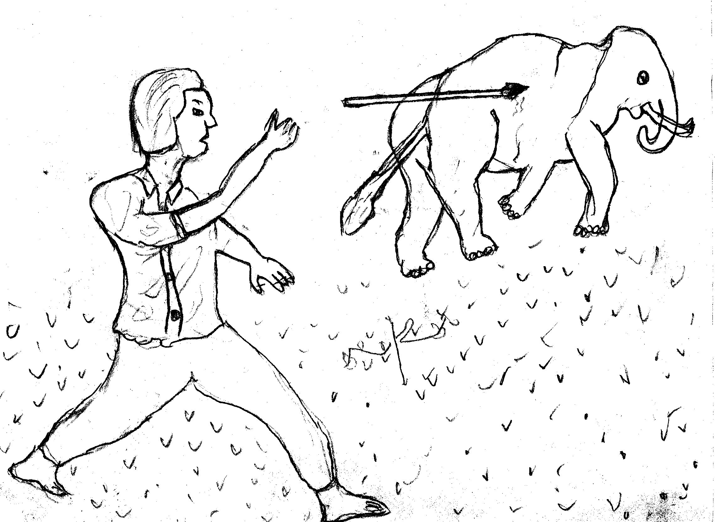
Munyo jadwoŋ me okidho i ndelo onwaŋo kir kama go ofuro jye dudi otwi iye.
Nitye jawodhe ma onwaŋo go i ndelo to wacho rigo ni, “Nitye gima bino wero i ndelo perin ka otieki furo to dudi twi. Ere dikin ipondi ibino neno.”
Yaweremere jadwoŋ me doko odhiro dhako gi nyithindho kidho doyo mwogo. To jadwoŋ me pondo. Munyo dhako gi nyithindho jotieko doy, gowacho ri dhako umo go gi lum aka jodoki.
Winyo me doko obino to nwaŋo ndelo ler to chako wer. Jadwoŋ me ogoyo winyo no, to neko.

Gi: Nyafwono Connie

