Fwonjo
PIASCY

Presidential Initiative on AIDS Strategy for Communication to Youth
Afwoyo jii jie mu konyan fwonjere gi kisoma Dhopadhola:

Edith Ajambo
Ekirapa Difas
Felistas Abbo
Geoffrey Owino
Grace Oyo
Irene Akello
Joselyn Anyango
Joyce Kataike
Lucy Amoit
Mary Oliŋa
Odoi John
Odoi Wambwe
Odwar Patrick
Oketcho Peter
Omalla Chombo Godfrey
Omitta Patrick
Oyuk-Oracho Julius
Wandera Melischisedek

Afwoyo jofwonji ma Nabuyoga gi jolan i kilas gi konyan fwonjo.

Afwoyo Okoth Mariko Risse mu chweyo fwonjirok moro.

Afwoyo Jose Wagi mu goyo ran picha ma aoro i kilas.

Afwoyo Ahmed Semwanga mu goyo picha i kitabo me.

Owor Kevin Rehak ondiko kitabo me ma konyo jofwonji fwonjo PIASCY gi miyo jii rieko ma geŋo twoo twilo.

Ondiko i dwe marapar g’aryo, 2004.
Gima ni Iye

Author’s Preface | 4
Thwoli gi Madalin | 5
Introduction to Puppet Shows | 7
Puppet Show Scripts:
Musa gi Ombula Pere | 9
Agnes Dongo | 11
Ochola Dongo | 12
Anyango Nyalo Timo Aŋo? | 12
Geŋo Pokopoko | 15
Ŋa ma Nitye gi Kudin ma Twoo Twilo? | 16
HIV Tag | 18
Kudin ma Twoo Twilo Neko Jii Nedi? | 20
Kigana | 22
Yeyo kosa Kwero | 23
Chweyo Kigana ma Nyien | 25
Frequently Asked Questions | 29
Resources | 35
Author’s Preface

One of the biggest challenges in fighting HIV/AIDS is knowing how to communicate with your audience. Some of the messages that you give to Primary 7 pupils may not be appropriate for Primary 3. Likewise, when you talk with parents, religious leaders, or community members, you may have to change your tone, message, or vocabulary.
This book contains the lessons I taught to Primary 5, 6, and 7 pupils in Nabuyoga Sub-County. Some people may not approve of the Dhopadhola words I used to describe the human body. I did not use them to be obscene; they are simply meant to be part of a serious discussion about HIV/AIDS and sexuality. I have thoroughly discussed this issue with teachers, headteachers, a CCT, and development workers. As the author of this book I feel it is important to use these words instead of euphemisms (for example, saying “the boy’s tail” instead of “penis”) when using them in a classroom setting. I feel very strongly that saying yiwi pa ja yach does not convey the serious tone needed for a science class. You will probably find, as I did, that the first time you say there, the pupils laugh. But they will quickly get used to it, and then the learning continues. It is the same in American schools when a teacher says “penis” for the first time. It is not meant to be obscene; it is simply the technical word. Also, these are the words that everyone knows; their meaning is straightforward.
If your audience is different, you can change the vocabulary to fit the occasion. For example, if you want to talk to parents, perhaps saying kalach instead of there will work better.
The most important question to remember is this: What method will work best to fight HIV? Think very hard about this before you begin your lesson. Everyone must make his or her own decision.
Thwoli gi Madalin

This is a simple, fun, and popular game that you can use to teach about many topics. Make a board as shown on page 6. You can make it on a grain sack, manila, or whatever is locally available. If you make the board very big, then many children can sit around it and be involved in the lesson. You will also need one dice and two different colored bottle tops. Also, make two groups of cards: the snake cards and the ladder cards. Write each of the phrases below on each card. There are 8 snake cards and 8 ladder cards.
Divide the class into two teams. Give each team a bottle top to move around the board. The first team rolls the dice and moves the number of spaces shown on the dice. Then the second team has its turn, and so on. When a team lands at the bottom of a ladder or on a snake’s head, they pick a card from the corresponding stack and read it. Discuss with the class why that statement was either a “snake” or a “ladder.” After discussing, move the piece to the top of the ladder, or to the tail of the snake, as necessary. Continue the game until one of the teams reaches square #100.

Thwoli
Alworo kwero ri jii ka jokwayan timo chot gi jo.
Kawinjo pokopoko kwoŋ timo chot awacho ri merin
paran bende.
Aoro kondom ma hongo mere orumo.
Chworan nitye gi mon man/Anitye gi mon man.
Amadho koŋo kweth kisindelo.
Aparo ni anyalo limo kudin ma twoo twilo ka suna kayan.
Atimo chot gi jii kweth to akiori kondom.
Akadho woko wor akendan.
Fwodi akipenjo dhano moro jie kwoŋ kudin ma twoo
twilo.

Madalin
Awon agwoko del kwoŋan.
Aŋeyo ni ombula man konyo kudin ma twoo twilo donjo
kwoŋan.
Amito chowo kilas abiriyo.
Aŋeyo oro kondom.
Akwero timo chot tundo nywomirok.
Agwokere kwoŋ jo ŋaŋo ma jo dwoŋo jo.
Akilwori penjo jofwonji kwoŋ timo chot kodi gi ma mako
kwoŋan.
Akuro josilim rupiri aŋeyo ni joripo kwo kodi limo kony.
Aŋeyo nger jie ma limo kudin ma twoo twilo.
Akilworo kadho pimirok.

You can also make more cards to teach about different things, such as hygiene, sanitation, malaria, or any other thing you can think of.
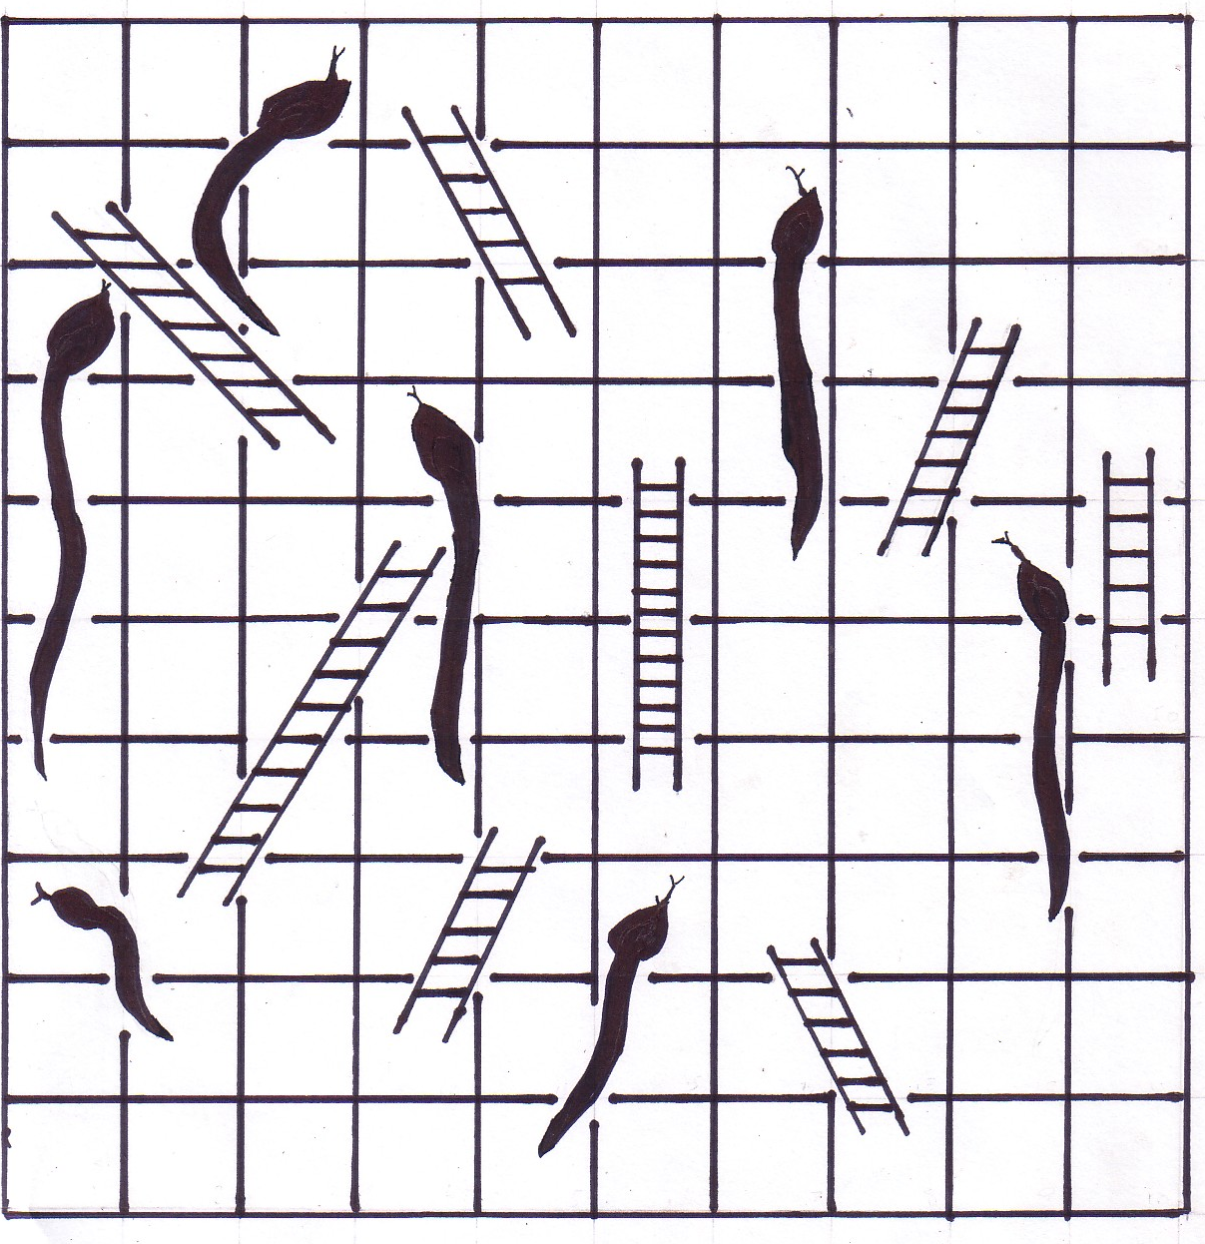

100

99

97

96

95

94

93

92

91

81

83

86

88

89

90

71

73

75

77

78

62

63

65

66

68

69

70

59

58

56

54

53

50

48

47

45

42

49

40

39

38

37

36

35

34

33

32

31

30

29

28

27

25

24

23

22

11

10

12

9

8

13

7

14

6

15

16

5

4

17

18

3

2

20

1

19

72
Introduction to Puppet Shows

Puppet shows are special dramas that use small objects called “puppets” to represent people. I have included instructions for how to make a very simple puppet from an old bottle of juice or mineral water. The presenter can sit behind a lesu held by two pupils so that the class sees only the puppets, but not the teacher. Then the teacher reads the words from one of the following scripts while holding the puppets above the lesu.
Puppets allow the presenter and the audience to become involved with a lesson without the usual pressures of talking about taboo subjects. The class sees the puppets talking, not the teacher. The following puppet shows are designed to introduce a subject in a creative, yet serious manner. I have used all of these with great success. But you cannot simply perform the puppet shows. They are meant as an introduction to a discussion. They raise questions. Answer those questions. Once you have gotten the practice of doing these puppet shows, you can write more for any other topic.
Note: words that appear in [brackets] are directions to the presenter and should not to spoken.

How to Make a Simple Puppet

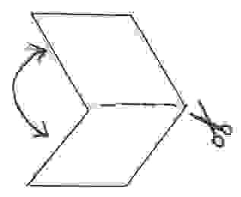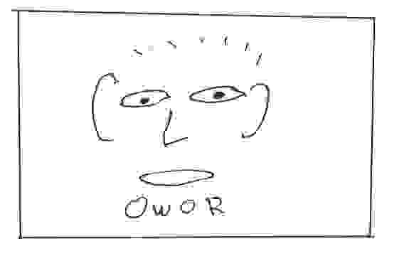
Step 1: Fold a piece of paper in half from top to bottom and cut along the crease.
Step 2: Draw a face on one of the halves of paper. Be sure to give your puppet a name.

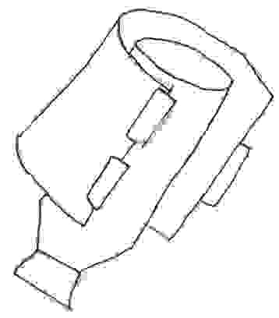
Step 3: Tape one side of the paper to an old bottle of mineral water. Wrap the paper around the bottle and tape the other side to the bottle.
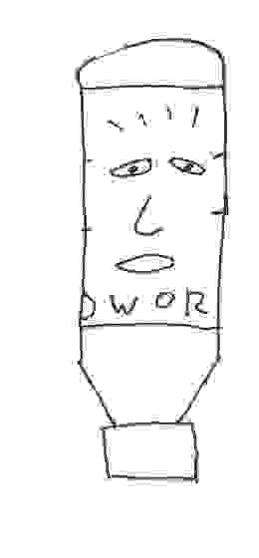
Step 4: You have finished! Make as many puppets as you need.

Musa gi Ombula Pere

You can use this puppet show to introduce a lesson about other STIs/STDs.

Scene 1
Musa: Yoga Okello!
Okello: Yoga bende Musa!
Musa: Initye nedi?
Okello: Anitye ma ber, kosa in?
Musa: Anitye ma rach. Achandere swa!
Okello: Iraŋo? Otimi nedi?
Musa: Akuya. To theran otula ka awinjo litho kalayo.
Okello: Iwinjo litho kilayo? Ah, ah, ah. Miti, ilimo
ombula.
Musa: Twoo mene?
Okello: Ombula ma nwaŋo i chot.
Musa: Aliŋin! Ikiri wachi ameno kwoŋan!
Okello: Akiwacho gi tuko bee. Kitimo chot m’ongoye
kondom, inyalo limo ombula. To kinitye gi
ombula, sawa moro iwinjo litho kilayo.
Musa: To nyako paran lworo kondoms swa.
Okello: Go ripo lworo ombula loyo.
Musa: To atimaŋo?
Okello: In kodi nyako perin, wiripo kidho dwaliro limo
yen.
Musa: Aŋo malatimere ka wakikidho i dwaliro?
Okello: Ka wikikidho i dwaliro, twoo lanyai win. To
bende, ka ombula bedo hongo malach kweth,
ikinyal nywol!
Musa: To ilimo rieko me kune?
Okello: Neran obedo jafwonji ma fwonjo gwokirok ma
twoo twilo ma TASO. Walyesa swa kwoŋ kuro
kwo.
Musa: Aya! Alaparo kwoŋ kidho i dwaliro.
Okello: Aya! Tundi ma ber.
Musa: Wananen chon.

Scene 2
Musa: Kodi kodi!
Musawo: Karibu!
Musa: Walwa musawo.
Musawo: Walwa bende. Maramin?
Musa: Awinjo litho kalayo. Anitye gi ombula?
Musawo: Eee! To ranyuth man nitye?
Musa: Gi mutula moro nitye theran bende.
Musawo: Eh! Eh! Eh! Ineno ranyuth keraŋo?
Musa: Aneno ranyuth ma mukaga m’orumo. Iraŋo
ipenjan ameno?
Musawo: Rupiri, kikibothere ombula piyopiyo, twoo
lanyai. To ka twoo bedo, ikinyal nywol.
Musa: Mere paran owacho ran ni wach adyeri!
Musawo. Eee! To initye gi nyiri adi?
Musa: Anitye gi nyako achiel kende.
Musawo: Go nitye kune?
Musa: Go nitye pecho pere. Iraŋ ipenjo?
Musawo: Rupiri wiripo bino kanyachiel ma limo yen.
Musa: Iraŋo?
Musawo: Rupiri, kiboth kendin, to go kuboth, inyalo limo
twoo bothi go kendo.
Musa: Aniaŋ. To wanyalo geŋo ombula me nedi?
Musawo: Marapena, wiripo chowo mwonyo yen jie.
Mararyo, wiripo kadho kipima remo mewin ma
ŋeyo ni winitye gi kudin ma twoo twilo kosa bee.
Maradek, wiripo weyo timo chot tundo nymomirok. Kawikinyalo weyo timo chot, wiripo oro kondoms kisi timo chot. Bende, in kodi go, wikiri timo chot gi ŋat man.
Musa: Ah! To meno tek, maa!
Musawo: Aŋeyo ni obedo gima tek, to meno nger ma
geŋo kudin ma twoo twilo gi ombula.
Musa: Aya. Weyan adoko. Alawacho ri nyako paran
rieko me.
Musawo. Kale. To fwoyi mere perin bende. Go konyin
swa!
Musa: Ikonyan bende. Afwoyin swa.
Musawo: Nyakadech.

Agnes Dongo

You can use this puppet show to introduce a lesson about body changes in girls.

SWT [Senior Woman Teacher]: Agnes! Biye!
Agnes: Wanji?
SWT: Iraŋo ikitundo sikul kononi?
Agnes: Atwo.
SWT: Ikichal ni itwo.
Agnes: Hmm.
SWT: Maramin?
Agnes: Akuya, to remo oyi kwoŋan.
SWT: Remo? Kune?
Agnes: Ŋonyan.
SWT: Ah, Agnes, ikiri rembi! Ikitwo!
Agnes: Akitwo?
SWT: Bee, iruko dwe kende. Nyiri jie ruko dwe.
Agnes: To in?
SWT: Hee, achako ruko dwe chango chon i kilas abiriyo.
Agnes: To an, fwodi anitye i kilas abich.
SWT: Kisi nyako bedo gi oro pere ma ruko dwe. Nyiri
man jo chako i sinia mararyo.
Agnes: Adyeri?
SWT: Hee.
Agnes: To, anyalo timo chot sawa me?
SWT: Ah, ah, ah. Ruko dwe kubedo gimanyuthin chako
timo chot. Kitimo chot, inyalo limo iyin, to kilimo
iyin, iripo weyo sikul. Bende, kitimo chot, inyalo
limo twoo twilo.
Agnes: Ah, afwonjere swa kononi!
SWT: Kinitye gi penji moro jie, inyalo penjan.
Ochola Dongo

You can use this puppet show to introduce a lesson about body changes in boys.

Jafwonji: Aya. Kilas, sawa me wasoma kwan. Andiko
gimoro i wimbawo. Apenjini awuchiel kodi adek
obedo adi? Ŋa ma ŋeyo radwok? Kilas? [He
pauses.] Ochola, biye. Ndiki radwok i wimbawo.
Ochola. Akuya.
Jafwonji: Kidwokani ikichungi?
Ochola: Akinyal ayi.
Jafwonji: Initye g’adhola i tyendin?
Ochola: Bee.
Jafwonji: Ibedo nedi?
Ochola: Ongoye.
Jafwonji: Ayi!
Ochola: [He pauses, then stands. There is no puppet to
represent the class, but the presenter should say
“Ha ha ha” to show that the class is laughing.]
Jafwonji: Ah, ah, ah. Ochola, bedi. Kilas, aliŋ win! Onyo,
iraŋo winyero? Rupiri there p’Ochola otelo? [He
pauses.] Aya, sawa me walawiro subject. Sawa
me wasoma science. Yach kweth i praimari
nwaŋo ni there pajo otelo sawa moro jie. Abende,
munyo afwodi soma praimari, theran otelo i kilas.
[The class laughs “Ha ha ha” again.] Abedo
serious, ma! Ka therin otelo, obedo gima
kisindelo. Onyo, walyesa. Ŋa nitye gi penji kwoŋ
dongo pa’ndel pa yach?

Anyango Nyalo Timo Aŋo?

This puppet show is different for two reasons: a) it has no end and b) there are many scenes. It is up to the pupils to create the ending for theirselves based on what they have seen in the earlier parts of the show. When you have finished with scene 5, get a volunteer to be each of the characters: Anyango, Nyawere, and Oketch. They will hold the puppets as they perform. They can do and say whatever they want, as long as it fits with the earlier parts of the drama. As the teacher, you can stop the drama when you feel they have done enough. Once the pupils have finished, begin a discussion about what happened during the puppet show and why.
After each of the scenes, take a moment to review the action of each scene, and ask the class, “Anyango nyalo timo aŋo?” Ask why they gave the answers they did. Give many pupils a chance to speak.

Scene 1 (Tich aryo)
Anyango: Yoga Nyawere!
Nyawere: Yoga bende Anyango!
Anyango: Initye nedi?
Nyawere: Anitye ma ber, kosa in?
Anyango: Anitye.
Nyawere: Awinjo ni neran lanywomo i mukaga me.
Anyango: Hee! Ilakidho?
Nyawere: Hee! Asangala swa kidho! Walachiemo,
walawero, walamielo!
Anyango: Mbaga labedo kune?
Nyawere: Labedo Miwafu. Wanokidhi?
Anyango: Akuya. Waladwoko sawa adi?
Nyawere: Akuya, to akidewo. Walakisangala swa!

Scene 2 (Tich adek)
Anyango: Nyawere, amito kidho i mbaga kodin.
Nyawere: Bas. Walakidho sawa apar.
Anyango: Kale. To, kawadwoko, walawotho nedi wor?
Nyawere: Walabedo wor gipi! Waladwoko odikini!
Anyango: To aparo ni…[She pauses.]
Nyawere: Aŋo?
Anyango: Ikiri rembi. Alalimin i mukaga!

Scene 3 (Mukaga wor, sawa adek)
Nyawere: Aya! Neni yach kweth ma beyo! Jo mielo ma
ber swa.
Anyango: Meno ilwoŋo go nedi?
Nyawere: Akuya. Kidhi penji go!
Anyango: Alworo penjo go. Fwodi akineno go. Ŋa ma
nyalo nyutho go wan?
Nyawere: Akuya. Kidhi mieli chiegin gi go.
Anyango: To nyiri ma dongo kweth nitye koro, go
kilanenan.
Nyawere: Iraŋo irembo?
Anyango: Rupiri jo nitye gi thundho ma dongo, to an,
anitye gi thundho ma thin.
Nyawere: Anyango, wabino ka ywaki? Kosa kisangala?
Kikikidhi kilyesa gi go, alakidho.

Scene 4 (Mukaga wor, sawa aŋwen)
Oketch: Amaro weri me swa! Jose Chameleon loyo jie!
Anyango: Ee, amaro go bende. [They dance.]
Oketch: Onyo, amarin.
Anyango: Hmm.
Oketch: Abedo serious, maa! Nyiri ma thoth jo kubedo
mbulaa. To in, fwodi bedo nyako mbulaa.
Anyango: Hmm. [They continue dancing.]
Oketch: Riyo nekan. To in?
Anyango: Hee.
Oketch: Weyi adwoko gi soda. Imadho soda mene?
Anyango: Keli ran Fanta.
Oketch: Aya. [He fetches the sodas and then they drink.]
Anyango: Ah! Fanta me lake kech.
Oketch: Ikiri rembi. Amedo nguli moro iye.
Anyango: Iraŋo?
Oketch: Iraŋo? Rupiri wanitye mbaga! Ikimadhi? Ilworo?
Anyango: Bee! Auro kende. [She pauses.]

Scene 5 (Mukaga wor, sawa abich)
Anyango: Aol, to wiyan wiran awira bende.
Oketch: Aparo ni imito koyo. Biye, wawoki woko.
Anyango: Inen mere paran ma nende abino gine?
Oketch: Ikiri rembi kwoŋ go. Wakadhi.
Anyango: To waladwoko kanyachiel. Akimiti weyo go.
Oketch: Wakidho dwoko sawa me.
Anyango: Nyawere!
Oketch: Wakadhi!

At this point, the teacher gets two volunteers from the class to act the parts of Oketch, Anyango, and Nyawere. Let them hold the puppets as they act. The idea is that the students get practice saying “No!” to a person asking them for sex. Pupils will be better able to say “no” in real life when they have had practice doing so in class. It is a good idea to do two rounds of the ending. Do one where boys play boys’ parts and girls play girls’ parts. Then switch so that the boys play girls’ parts and the girls play boys’ parts. When the pupils switch parts, it allows them to get the perspective of the other person. Boys can understand how girls feel when they are asked for sex, and girls understand what the boys are thinking when they ask for sex.

Geŋo Pokopoko

This is a drama performed with the teacher and a pupil. The __ spaces are for the teacher to say the name of the pupil who does the acting. The pupil never speaks; he or she only acts what the teacher reads. After reading every paragraph, the teacher allows the pupil time to do the task the teacher has talked about. You can enhance the drama by bringing any props (things to help show a drama) like a basin and a plate.
When you have finished doing the drama, you can begin a discussion about the ways HIV is transmitted and is not transmitted. You can also talk about the proper way to treat people living with HIV/AIDS (you can still share a meal with that person, shake their hand, etc.).

Jii jie neni __. __, mothijo.
To __, i drama me, ikinyal luwo. Mothijo m’ongoye gi luwo.
Ndelo achiel, __ chiewo. Marapena go ripo timo tich pere. Mama __ nitye gi silim. Go wacho ri __ ni, “Lwoki nangin paran.”
Gikenyo, __ kadho sikul. I dhoyo go neno mere pere. Jo mothere.
Jo kadho sikul kanyachiel, jo makere chingini.
Ka breaktime tundo nythindho jie tuko. __ gweyo mupira gi merin pere.
Sawa apar go doko. Go luwo pecho pa nyako [or “ja yach,” if a girl performs this drama]. Nyako [ja yach] obedo kendego. Nyako [ja yach] kwayo __ ma timo chot, to __ daki swa.
Ka go tyeko doko, kech neko __. Go nwaŋo chiemo ma ŋich nitye sen pa Mama pere, to chiemo man ongoye. __ chiemo.
Gikenyo, __ kadho kwayo dyegi pere. Ka go dwoko, go mito lwokere. To Mama pere otyeko oro bafu. __ lwokere.
Sawa aŋwen ma wor __ ol swa. Go kisangala swa rupiri go ŋeyo ni kunwaŋo silim konon. Nindi ma ber, __.

Ŋa ma Nitye gi Kudin ma Twoo Twilo?

As shown on page 17, cut out a picture of a person from a magazine or newspaper or any other place. Glue the picture to a blank sheet of paper. Then create a brief description of the person and write it below the picture. You can mention the person’s age, name, the work he or she does, or any other thing. On the back of the paper, write either “HIV +” or “HIV-.”
Show several of the pictures to the class, but do not allow them to see what you have written on the back. Ask the pupils if they think the people in the pictures have HIV or not. Ask them why they answered the way they did. You can then begin a discussion about stigma and discrimination of people with HIV. Would you still want this person to be your friend? If this person was your mother or father, how would you feel about him or her? How would you feel if people thought you had HIV only because you had a certain appearance or did a certain behavior? And don’t forget to mention that you can only know if a person has HIV by going for a test.

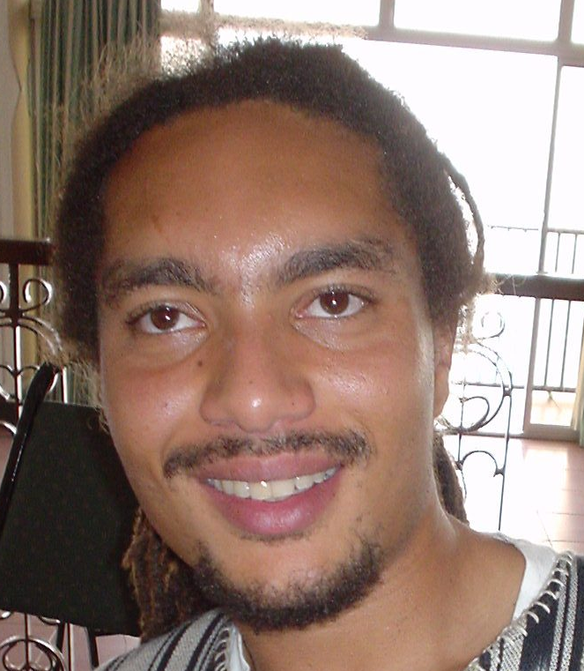

Jadwoŋ me ilwoŋo go ni Ofwono Thomas. Obedo chairman ma LC 1.
Here are more suggested descriptions:

1. Jadwoŋ me ilwoŋo go ni Michael. Gojaŋwech ma
Manchester United.
2. Jadwoŋ me gi dhakodwoŋ me jo nywomere. Jadwoŋ
me jafur. Dhakodwoŋ me pidho nyathi pajo.
3. Nyathi kich me ilwoŋo go ni Akello Jostina. Bamere
otho to minigo fwodi kwo.
4. Ja yach me ilwoŋo go ni Owor Peter. Go soma kilas
aŋwen. Kis ka go dwoko, gokwayo dhoki.
5. Nyako me ilwoŋo go ni Awino Sara. Go fwodi soma.
Go nitye i sinia maradek.
6. Dhakodwoŋ me ilwoŋo go ni Susan. Go jafwonji ma
sekondari sikul. Go ja oro pyero aŋwen gi awuchiel.
7. Jadowŋ me ilwoŋo go ni Oboth Jackson. Go jaweri. Go
nitye gi pesa kweth. Go wotha wotha tundo Lagos, Nairobi, kodi Kampala.
8. Jadwoŋ me ilwoŋo go ni Odoi Henry. Go jagweyi taxi.
Go nitye gi mon aryo.
9. Jadwoŋ me ilwoŋo go ni Major Osinde. Go ja oro
pyero abich gi achiel. Go timo tich malweny i Bombo Barracks.

HIV Tag

Before starting this activity, the teacher will make 12 signs that can be worn by students (see Diagram 1, pg. 20).

1. Atimo chot gi dhako m’odakana, to akioro kondom.
Anyalo por apipili kende.
2. Atimo chot gi jii kweth, to aoro kondom sawa moro.
Anyalo por kende.
3. Anwaŋo sirinji ma atuko gine. Anyalo redo kende.
4. Chworan nitye gi dhako man. Anyalo redo kende.
5. Chworan kadho Kampala, to go timo chot koro. Fwodi
akioro kondom gi go. Anyalo por kende.
6. Atimo chot gi jii kweth, to akioro kondom. Anyalo por
apipili kende.

Make two signs for each statement written above. In this game, the teacher finds 12 volunteers from the class. Each of the volunteers wears one of the signs. Have each person read his or her sign, and emphasize that they can not run; they can only “redo,” “por,” etc. As the facilitator, you play the HIV virus. The children “get” the virus when they are touched on the arm by the teacher. Go outside to start the game. The teacher chases the children around the playing field, and tries to touch their arms. If you find that all of the children run, including the ones wearing the signs, call them back, explain the rules a second time, and start again. Any pupil with a sign who continues to run automatically “gets” the virus.
After a few minutes, call all the children to return to the classroom. Ask the children who were touched to come to the front of the class. What usually happens is that most, but not all, of the students with signs come forward. A few students without signs may also come forward.
Now you can begin a discussion. Why did these children get the HIV virus? What about the ones who didn’t have any risk behaviors? What can the ones with signs do to change their behavior? Of the children with signs who did not get caught, what would happen if you continued to play the game for ten minutes? Or twenty? Answer all of the questions that the pupils have.
At the end of the lesson, remind the pupils that the people who wore the signs do not do those things in real life. It was just for a demonstration.

Atimo chot gi dhako m’odakana, to akioro kondom.

Anyalo por apilili kende.
Use string or banana fiber
Use manila or old paperboard

Diagram 1

Kudin ma Twoo Twilo Neko Jii Nedi?

For this game, you will need 14 signs, made like the ones used in HIV Tag (Diagram 1). But the words are different. Ten of the signs have the words “White Blood Cell.” The other four say either “Wolo,” “Senyiga,” “Dyewo,” or “Musuja.” Start the period by asking the pupils what they know about the virus, and its relationship to AIDS. Also ask them what is the role of the white blood cells in the body. Get 15 volunteers from the class; 14 of them wear the signs, and one does not. The one who does not have any sign is the “person” in this activity. Everyone else is either a “white blood cell” or a “disease.” The rest of the pupils watch and listen.
Give a kavera ball to one of the diseases. Ask the disease to throw the kavera ball at the person. When the disease throws the ball and hits the person, the person becomes “sick.” But the person is not alone. The white blood cells protect the person by blocking the ball. Take the class outside, and have the white blood cells surround the person, and the diseases stand outside, about 10 feet away from the circle. Then they try and hit the person with the ball. The white blood cells will protect the person.
Now, tell the class that the person has 18 years, and is healthy. But then, on the person’s 19th birthday, he or she went to Kampala, played sex, and got HIV. Explain that the HIV virus slowly eats the white blood cells. The diseases continue to throw the ball, and after every few throws, the teacher says, “Go medere or’achiel man,” and the teacher pulls one more white blood cell away. Sometimes, one of the diseases will hit the person. You can explain this by saying that everyone, HIV positive or negative, gets a cough (or diarrhea or whatever) sometimes. By the end, there will be no more white blood cells remaining, and every disease will hit the person. Explain that this is now AIDS. There are no more white blood cells, and many other diseases are infecting the person. All of the time that the person had the virus, he or she looked healthy, felt strong, but was able to give the virus to someone else if they played sex, or shared a sharp object. Answer any questions that the pupils have.
As with the HIV tag game, explain to the class that the person does not really have HIV, and give them a clap for playing the game so well.

Kigana

Each of these stories describes one of the methods of transmitting HIV: sexual intercourse, mother-to-child-transmission, and sharing of sharp objects. Read the stories to the class. Ask them questions about the story. What happened? Why? What could have been different? What did they learn? What would they do if they found themselves in this situation?

Kigana Marapena: “Awino Ripo Sikul Fees”

Obedo nyako ma Kiyeyi Sekondari nyinge Awino. Munyo Awino nitye i sinia marachiel go oripo chulo sikul fees. Bende nitye jakitana nyinge ni Oboth. Go obedo i chalo achiel gi Awino.
Ndel’achiel Awino onyewo kitabin both go. Oboth owacho ri go ni, “Biye, amito ni iwend pecho paran. Alakonyin gi chulo sikul fees.
Awino odwoko ni, “Ee.”
Ndelo moro Awino okidho wendo p’Oboth. Go owacho ri Awino ni, “Donji ot.”
Awino oparo ni rach, to rupiri go omito sikul fees swa, go odonjo. Awino onwaŋo ni dhako p’Oboth ongoye. Muny’Oboth otero go kanindo, Awino olworo swa. Go oŋwecho ŋwecha swa tundo woko, to onwaŋo mere pere. Jo oromo gi jafwonji ma dwoŋ, to Awino osa ri go.
Rupiri jo otimo ameno, sawa me nyiri jie ma Kiyeyi Sekondari jo ŋeyo ni Oboth rach.

Kigana Mararyo: “Alweny gi Nyathi Pere”

Obedo dhakodwoŋ moro ma Siwa nyinge Alweny. Alweny nitye gi kudin ma twoo twilo, to kudin ma twoo twilo nitye chak thundho pere bende. Munyo go onywolo nyathi pere, nyathi ongoye gi kudin ma twoo twilo. To rupiri Alweny olworo miyo nyathi kudin ma twoo twilo, go oparo ni omiyo nyathi chak dhiaŋ sawa moro, to go odhoth sawa man. Nyathi olimo kudin, t’otho.
Munyo nyathi p’Alweny tyeko otho, Alweny romo mere pere. Mere bende nitye gi kudin ma twoo twilo. To munyo mere onywolo, go okidho dwaliro, to openjo jo konyo. Jo owacho ri mere ni, “Dhothi kende tundo dwe awuchiel. Ikiri miyi go chiemo man. Aka dwe awuchiel bino, miyi go chiemo man kende. Weyi dhotho.” To nyathi no kuro kwo.

Kigana Maradek: “Ochieŋ Tuko Ma Rach”

Obedo ja yach moro ma Mulanda, nyinge Ochieŋ. Ndelo achiel Ochieŋ oido tuko mupira. Go oneno gimoro ma pilin i lum. Go omako gi no, aka no bedo piso gi sirinji, ma remo moro fwodi nitye iye.
Ochieŋ oparo kwoŋ tuko gi mere pere. Owok yuchien to ochwowo mere pere i chinge. Munyo oro aryo orumo, mere pere otho rupiri go olimo kudin ma twoo twilo wok sirinji p’Ochieŋ.

Yeyo kosa Kwero

This game reviews the basic knowledge of HIV. Get 20 volunteers and go outside under a tree. Divide them into two teams of ten each. They sit on the ground in a line, facing each other. Place two markers (a brick and a jerrycan, or whatever is locally available) about 15 feet away from the lines. Tell the class that one of them is “Yeyo” and the other one is “Kwero.”
Read one of the statements below. After you have finished reading, the first pupil from each line runs to either “Yeyo” or “Kwero.” The student who arrives first gets the first chance to say why he or she chose that answer. If the pupil gives a correct response, then that team gets 2 points. If the other team reached the correct answer, but arrived second, give that team 1 point. If they reach the correct answer, but have no reason, let the other team try. If no correct answers are reached, and no reasons given, give no points. Then the next pupils in the line repeat the game with the second statement. Continue until the lines are finished. The team with the most points wins. If there is a draw after 10 questions, then you can ask the 11th question. Correct answers are in [brackets].

1. Kimakere chingini, inyalo limo silim. [Kwero]
2. Ka dhako nitye gi silim, kudin ma twoo twilo nitye
chak thundho pere bende. [Yeyo]
3. Kitimo chot gi dhako m’odakana, m’ongoye kondom,
inyalo limo silim. [Yeyo]
4. Ka dhano moro wolo bongin, inyalo limo silim.
[Kwero]
5. Kichamo chiemo tedere gi jasilim, inyalo limo silim.
[Kwero]
6. Ka remo m’odhiek nitye i kamwueso, to ihemere gine,
inyalo limo silim. [Yeyo]
7. Inyalo oro kondom aryo kanyachiel ma geŋo silim
loyo. [Kwero]
8. Kwero timo chot bedo royo ma loyo jie ma geŋo silim.
[Yeyo]
9. Dhako ma nitye gi silim onyalo nywolo nyathi
m’ongoye gi silim. [Yeyo]
10. Ka jomusawo kuro josilim, jomusawo lalimo silim
bende. [Kwero]
11. [Use only if there has been a draw]. Inyalo limo silim
wok kwoŋ ogwange. [Kwero]

Chweyo Kigana ma Nyien

The three pictures on pages 26, 27, and 28 are the basis for stories. Show the pictures in the book to the class. If there is a good artist at your school, he or she can draw the pictures on grain sacks. Ask the class to create a story based on what they see in the picture. There are no wrong answers. If the class has trouble starting, you can help them by asking some simple questions, such as, “What are the names of the people you see?” “How old are they?” “Where is this happening?”
As the pupils begin to create a story, you can ask more questions about it. Get them to give you many details. Listen to the story they have created, and decide which PIASCY message best relates to that story, and then begin a discussion about that message.
Each story that each class creates will be different. I have used the same picture with different classes and one came up with a story about family planning, and another came up with a story about saying no to gifts for sex. As the teacher, you must be very attentive and flexible when you do this lesson.
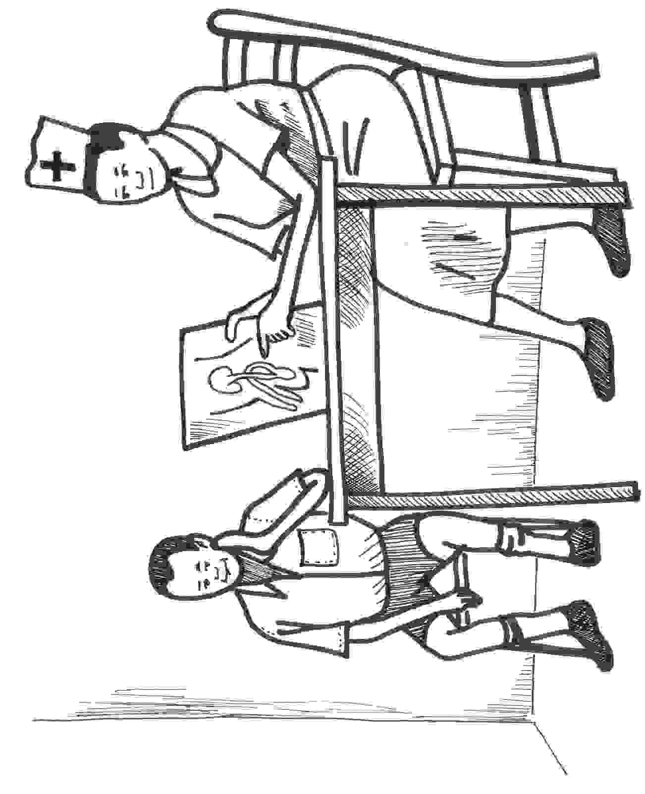
Picture 1

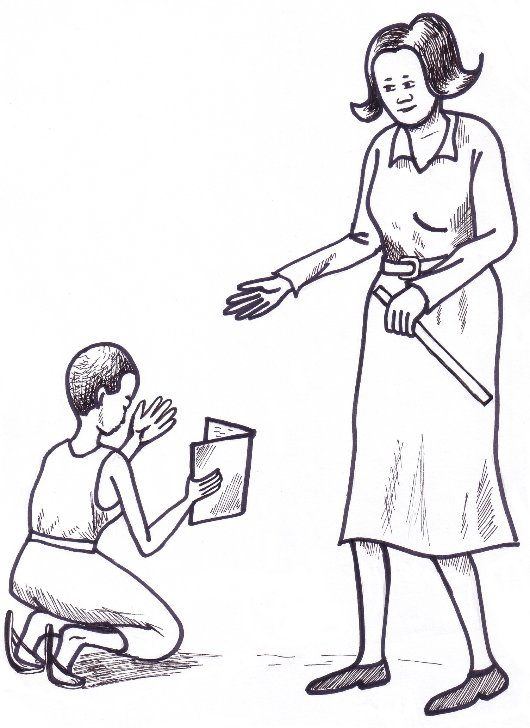

Picture 2

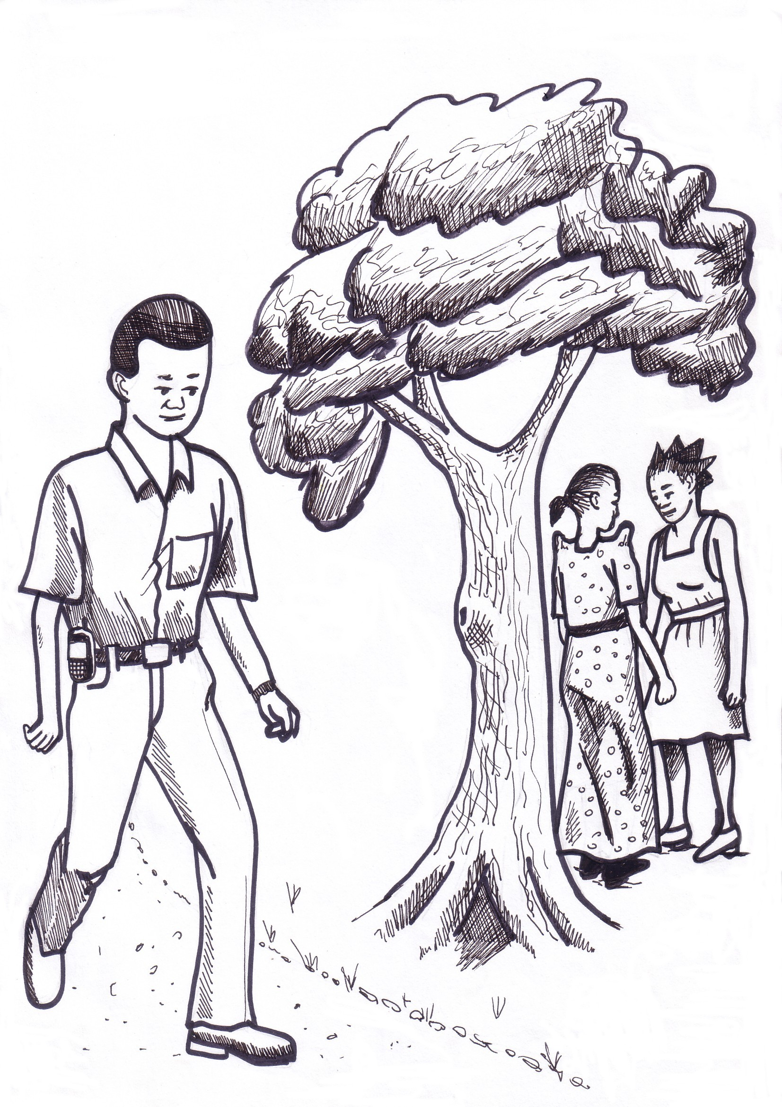

Picture 3
Frequently Asked Questions

Your pupils will always have many questions about HIV/AIDS, sex, their bodies, and related topics. These are the questions I heard most frequently.
It is very important to allow time at the end of every lesson for pupils to ask. Let them ask about anything; there are no “stupid” questions. Often you will find that other pupils laugh when one of their classmates asks a question, or says a word like ojayo. It is also very important that you, as the teacher, do not laugh. Remain serious and answer the question calmly, using the proper vocabulary. This will ensure that no student fears to ask. And when no one fears to ask, the class will learn more. And the more they learn, the better we will fight HIV.
Sometimes pupils may ask a question, and you may not know the answer. Don’t worry. Tell them whatever related facts you know, and then go and find the complete answer from a health worker, a book, or other resource. You can always invite resource persons to help you. For example, if you want to teach about body changes in girls, you can invite the midwife from the nearest health unit.

1. HIV obedo aŋo?
HIV ilwongo ni Human Immunodeficiency Virus i Luzungu. I Dhopadhola ilwongo ni kudin ma twoo twilo. Nitye i ojayo, pii ma ŋonye, gi chak thundho pa dhano ma tyeko limo kudin. Inyalo nwaŋo kudin me ka remo m’odhiek, ojayo, pii ma ŋonye kosa chak thundho odonjo kwoŋin. Kudin me chamo white blood cells pa jii, to medere mothi moth. Kudin me kelo twoo twilo (AIDS).

2. AIDS obedo aŋo?
AIDS ilwongo ni Acquired Immunodeficiency Syndrome i Luzungu. I Dhopadhola ilwongo ni silim kosa twoo twilo. I Luganda ilwongo ni mukenenya. Twoo twilo ramo dhano munyo kudin ma twoo twilo otyeko chamo white blood cells ma thoth. Dhano m’ongoye gi white blood cells pere, wiye mol, mok, dyewo, wolo tek tek kodi kwoŋe tula ma rach swa, t’otho.

3. Pokirok ma HIV gi AIDS obedo aŋo?
HIV obedo kudin ma kelo twoo AIDS. Paka suna kubedo musuja, to suna kelo musuja. Dhano nyalo bedo gi kudin ma twoo twilo ma oro kweth, to fwodi ongoye gi twoo twilo.

4. White blood cells obedo aŋo?
White blood cells obedo gikipiny ma thindho thindho ma geŋo twoo m’opokere. Jo bedo paka askari ma del. Jo nitye i remo pa kis dhano.

5. Anyalo limo kudin ma twoo twilo nedi?
Inyalo limo kudin ma twoo twilo kitimo chot gi dhano ma nitye gi kudin ma twoo twilo. I Uganda, jii pyero aboro gi aŋwen ma kis miya [84%] limo kudin ma twoo twilo anger me. Bende, jii aryo kende ma kisi miya [2%] limo kudin ma twoo twilo gi oro gikipiny ma bith pa dhano moro man, paka kamweso kosa piso, ka remo m’odhiek nitye. Nythindho ma thindho jo nyalo limo kudin ma twoo twilo ka yokijo nitye gi kudin ma twoo twilo. Jo nyalo limo ka fwodi jo nitye iyemin jo, i nywolirok kosa dhoth.

6. Anyalo geŋo kudin ma twoo twilo nedi?
Inyalo geŋo kudin ma twoo twilo gi ABC. Meno Abstain, Be Faithful, use Condom. Marapena, Abstaining obedo kwero timo chot tundo nywomirok. Meno nger ma ber loyo jie ma geŋo kudin ma twoo twilo. Mararyo, Be Faithful obedo dhako gi chwore jo kadho pimirok kanyachiel. Ka jo aryo ongoye gi kudin ma twoo twilo, jo timo chot kendejo; jo kidoki jo timo chot gi ŋat man. Condoms nyalo geŋo kudin ma twoo twilo, to jo ŋwecha ma ber safari pyero abuŋwen g’abich ma kis miya kende [95% effective only]. Condoms obedo ri jo dongo kosa mondongo ma kunyalo timo Abstaining kosa Be Faithful. Condoms dwoŋ ri theri yach. Jachwo gi dhako ma jo tyeko nywomere nyalo oro Condoms ma geŋo limo nyathi (timo Family Planning).

7. HIV positive gi HIV negative meno aŋo?
Ka dhano obedo HIV positive, go nitye gi kudin ma twoo twilo. Ka dhano obedo HIV negative, go ngoye gi kudin ma twoo twilo.

8. Alaŋeyo ni anitye gi kudin ma twoo twilo nedi?
Iripo kidho pimirok. Inyalo kidho pimirok i Tororo, kosa dwaliro moro i chalo.

9. Ranyuth ma kudin ma twoo twilo obedo aŋo?
Kudin ma twoo twilo ongoye gi ranyuth. Dhano ma nitye gi kudin ma twoo twilo nyalo chalo ni go kuro kwo ma ber. To ka dhano nitye gi twoo twilo, go mok, wiyego mol, kwoŋe tula nitye to wolo tek tek, aka del pere nyap.

10. Anyalo chako timo chot keraŋo?
I Uganda, chik nitye ma chiero timo chot ka fwodi ikitundo oro apar g’aboro. Meno bedo defilement. Kitundo oro no, ikiripi chako timo chot. Inyalo kuro tundo nywomirok. Iripo yeyo ma ber iwon.

11. Yath moro nitye ma botho twoo twilo?
Bee. Yath ma botho twoo twilo ongoye. To yen moro ma konyo jii ma nitye gi kudin ma twoo twilo ama nitye. Yen no ilwongo ni ARVs (Anti-Retro Virals). ARVs nyalo goyo kudin ma twoo twilo moro, to kinyal goyo kudin jie.

12. Anyalo oro kondoms aryo kanyachiel ma geŋo kudin ma twoo twilo?
Bee. Oro kondoms aryo kikony. Kondoms larudere, to jo bare piyo piyo.

13. Ka jachwo gi dhako jo aryo nitye gi kudin ma twoo twilo, jo nyalo nywolo nyathi m’ongoye gi kudin ma twoo twilo?
Ee, jo nyalo, rupiri kudin ma twoo twilo ongoye i tonge dhako gi sperms pa jachwo. Sperm donjo i tonge, to kudin kidonj. Nyathi nyalo dongo iye dhako, yo nywolere m’ongoye gi kudin ma twoo twilo.

14. Aŋo ma nitye i ojayo?
Ojayo nitye gi gikipiny aryo: sperms kodi semen. Sperms obedo gikipiny ma donjo i tonge dhako. Semen obedo pii ma kuro sperms. Ka jachwo nitye gi kudin ma twoo twilo, kudin bedo i semen kende; ongoye i sperms.

15. Nyiri nyalo telo?
Hee, nyiri bende jo telo.

16. Pii ma ŋonye timo aŋo?
Pii no konyo there donjo ŋonye munyo i timo chot. Ka dhako nitye gi kudin ma twoo twilo, kudin no bedo i pii no.

17. Ka jachwo timo chot, to go ywayo there ka ojayo fwodi kubino, dhako pere nyalo limo iye?
Hee, go nyalo limo iye, rupiri ojayo marapena bino ma nok; rumachien, ojayo ma thoth nyaka bino. “Sperms” ma wok i ojayo marapena nyalo donjo tonge dhako.

18. Kondom pa dhako nitye?
Hee, nitye, to nitye i tindi kende. Ongoye i chalo. Aka pesa kweth.

19. Anyalo tweyo kavera i theran katimo chot ma geŋo kudin ma twoo twilo?
Bee, tweyo kavera i therin kigeŋ kudin ma twoo twilo. Kikitimo chot bedo nger ma ber loyo ma geŋo kudin ma twoo twilo.

20. Akuri josilim nedi?
Iripo kuro josilim pa dhano moro jie. Jo ripo chiemo ma ber, iripo kilyesa gi jo, iripo kwayo gi jo, iripo tuko gi jo. Aka, ikiri nyeri jo. Aka, ka jasilim limo ARVs, go ripo mwony yen jie kisindelo; go kunyal wiro ARVs pere gi ŋat man.

21. Kudin ma twoo twilo owok kune?
Joscientists fwodi jo kuya radwok. Jo tiyo kisindelo ma ŋeyo. Jasilim marapena ma Uganda obedo Rakai i oro 1982.

22. STI meno aŋo?
STI obedo Sexually Transmitted Infection i Luzungu. Ilwongo ni STD, meno Sexually Transmitted Disease bende. I Dhopadhola ilwongo ni twoo chot. Obedo twoo ma dhano limo i timo chot. Twoo chot kweth nitye paka gonorrhea, syphilis, genital herpes, genital warts, candida, kodi chancroid.

23. Ranyuth ma twoo chot obedo aŋo?
Ranyuth obedo kitula, adhola, wotho gi maŋwe, winjo litho ka layo, layo tuti kosa yil ma there/ŋonye.

24. Ka dhano nitye gi twoo chot, go nitye gi kudin ma twoo twilo bende?
Sawa moro, ka twoo chot ramo dhano, kudin ma twoo twilo ramo go bende. To sawa moro man, twoo chot ramo dhano kende. To ka dhano nitye gi twoo chot, go nitye gi kibenga swa ma limo kudin ma twoo twilo rupiri kudin ma twoo twilo nyalo donjo i adhola ma there/ŋonye.

25. Alwoki theran/ŋonyan nedi?
Nyiri: Lwoki woko kende gi sabuni gi pii. Ikirip lwoko iye ŋonyin.
Yach: Lwoki there gipi gi sabuni. Peki wich there to lwoki iye.

26. Dhano nyalo limo silim both timo chot g’ogwange?
Bee. Poyi ni, HIV obedo “Human Immunodeficiency Virus.” Kudin ma twoo twilo nitye i jii kende. Kudin ongoye i ogwange. Odoko, ikiri timi chot g’ogwange. Meno gikipiny ma rach swa. Aka, ikinyal limo HIV ka suna kayin.

Resources

Alternative Techniques for Teaching about HIV/AIDS in the Classroom, Peace Corps Information Collection and Exchange (M0063): 2001

Callahan, Kathleen (ed.), Life Skills Manual, Peace Corps Information Collection and Exchange (R0086): 2001

Chin, James, MD, MPH, Control of Communicable Diseases Manual (17th edition), American Public Health Association, Washington, DC: 2000

Granich, Reuben, MD, MPH and Mermin, Jonathan, MD, MPH, HIV, Health and Your Community: A Guide for Action, Stanford University Press, Stanford, CA: 1999

Othieno, Catherine, Knowledge, Attitudes and Practices of Sexuality and HIV/AIDS/STDs among Children Aged 10-14 Years: The Case of Nabiyoga Sub-County, Tororo District, Pentecostal Church, Women Against AIDS Project (Funded by Research Foundation of Childhood Diseases of Finland): 2004

PIASCY: Helping Pupils to Stay Safe, Ministry of Education, Kampala: 2004

Policy Guidelines on Feeding of Infants and Young Children in the Context of HIV/AIDS, Ministry of Health, Kampala: 2001

Right to Play, http://www.righttoplay.com/countries_uganda.asp

